拓扑图
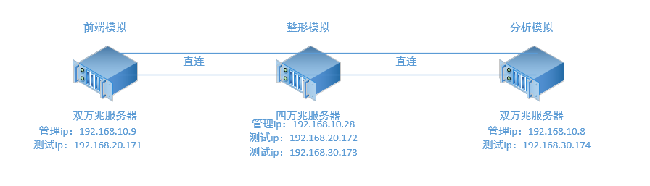

测试目标：
- centos7/centos8,协议栈收发TCP性能
- 前端带业务，使用tcp传输数据的性能与资源占用
- 1份输入，复制2份输出模式下，单机最大支持输入多少流量

准备工作：
- 4根万兆光纤和8个万兆模块
- 准备三台服务器centos7
- 接线直连

配置工作
- 说明
以192.168.10.8为例，找两个没有配置ip的网卡，用来做聚合的物理网卡，192.168.10.9同理，192.168.10.28需要4个网卡配置2个聚合用来跟192.168.10.8和192.168.10.9之间互通
- 前端模拟服务器创建链路聚合team1
nmcli connection add type team con-name team1 ifname team1 config '{"runner":{"name":"roundrobin"}}'
team的四种模式（在这里我们使用轮训模式）
- broadcast (广播模式)
- activebackup (主备模式)
- roundrobin (轮训模式)
- loadbalance (负载均衡) LACP

- 将两张新网卡添加到这个team1中并查看网卡状态
nmcli connection add type team-slave con-name p6p1 ifname p6p1 master team1
nmcli connection add type team-slave con-name p7p2 ifname p7p2 master team1
[root@localhost ~]# nmcli device status
DEVICE TYPE STATE CONNECTION
em1 ethernet connected em1
p6p1 ethernet connected p6p1
p7p2 ethernet connected p7p2
team1 team connected team1
- 配置team1的ip地址并修改BOOTPROTO=static,IPADDR=ip地址,PREFIX=24
Vim /etc/sysconfig/network-scripts/ifcfg-team1
DEVICE=team1
TEAM_CONFIG="{\"runner\":{\"name\":\"roundrobin\"}}"
DEVICETYPE=Team
BOOTPROTO=static
DEFROUTE=yes
IPV4_FAILURE_FATAL=no
IPV6INIT=yes
IPV6_AUTOCONF=yes
IPV6_DEFROUTE=yes
IPV6_FAILURE_FATAL=no
NAME=team1
UUID=7e5de1b0-f461-4bb6-bec8-e13c00204865
ONBOOT=yes
IPADDR=192.168.30.174
PREFIX=24
IPV6_PEERDNS=yes
IPV6_PEERROUTES=yes
- 重启网卡
systemctl restart network
- 查看聚合配置，p6p1与p7p2的mac地址相同

8: p7p1: <NO-CARRIER,BROADCAST,MULTICAST,UP> mtu 1500 qdisc mq state DOWN qlen 1000
link/ether e8:61:1f:18:ef:22 brd ff:ff:ff:ff:ff:ff
9: p7p2: <BROADCAST,MULTICAST,UP,LOWER_UP> mtu 1500 qdisc mq master team1 state UP qlen 1000
link/ether e8:61:1f:13:6a:a2 brd ff:ff:ff:ff:ff:ff
10: team1: <BROADCAST,MULTICAST,UP,LOWER_UP> mtu 1500 qdisc noqueue state UP qlen 1000
link/ether e8:61:1f:13:6a:a2 brd ff:ff:ff:ff:ff:ff
inet 192.168.30.174/24 brd 192.168.30.255 scope global team1
valid_lft forever preferred_lft forever
inet6 fe80::ea61:1fff:fe13:6aa2/64 scope link
valid_lft forever preferred_lft forever
- 查看聚合网卡状态
[root@localhost network-scripts]# teamdctl team1 state
setup:
runner: roundrobin
ports:
p6p1
link watches:
link summary: up
instance[link_watch_0]:
name: ethtool
link: up
down count: 4
p7p2
link watches:
link summary: up
instance[link_watch_0]:
name: ethtool
link: up
down count: 5
- 配置路由
  - 192.168.10.9配置路由
route add –host 192.168.20.172 dev team1
  - 192.168.10.28配置路由
route add –host 192.168.20.171 dev team1
route add –host 192.168.30.174 dev team2
  - 192.168.10.8配置路由
route add –host 192.168.30.173 dev team1
- 测试
  - 在192.168.10.28上执行[root@localhost ~]# qperf
  - 在192.168.10.9上执行
[root@localhost ~]# qperf 192.168.20.172 tcp_bw
tcp_bw:
bw = 1.79 GB/sec
  - bw = 1.79GB/sec达到效果

