塞米伊
- ADC端口的9和10连接错误。
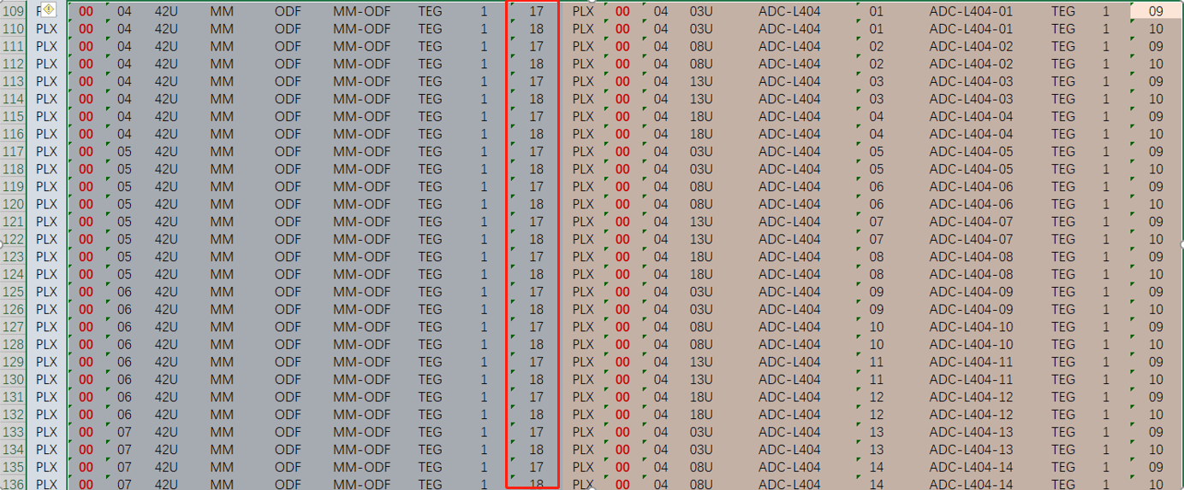
- 1机柜系统图和线表的U位置不对。
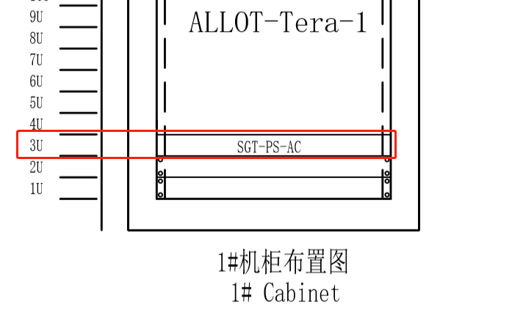
图中是03U.
表格是02U.
- 2机柜的STC编号没有写对。（写反了）
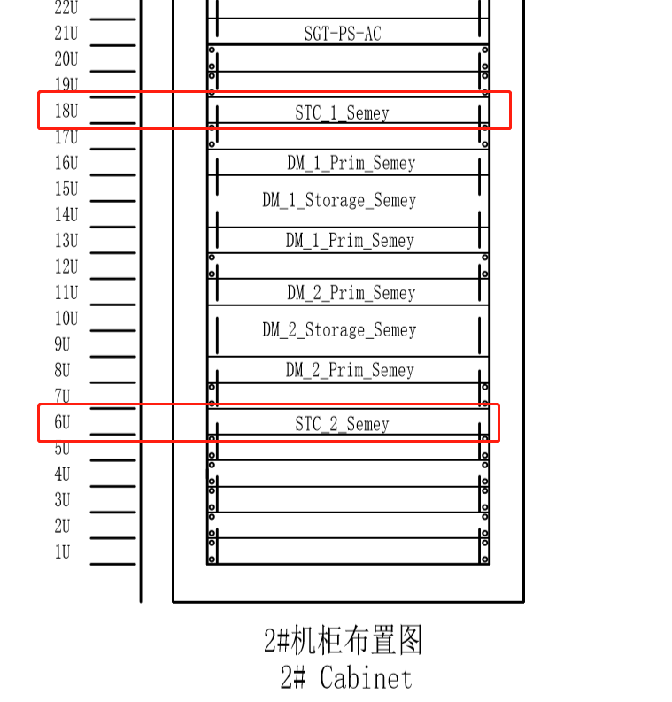
机柜位置：6U为STC-2 ; 18U为STC-1；
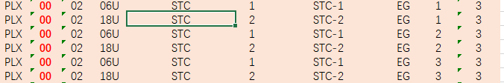
而线表的：6U为STC-1 ; 18U为STC-2；
- 2机柜的线表于系统图不服。
系统图：
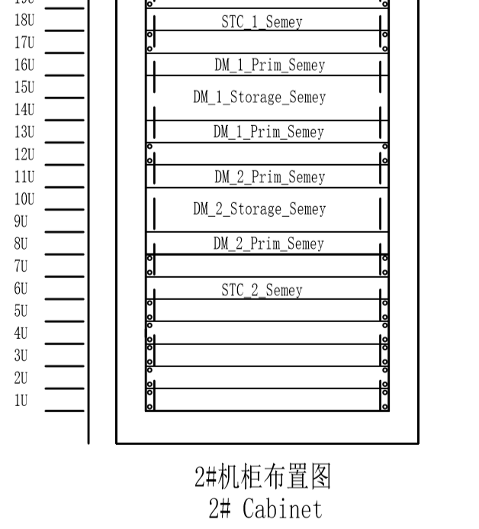
线表：
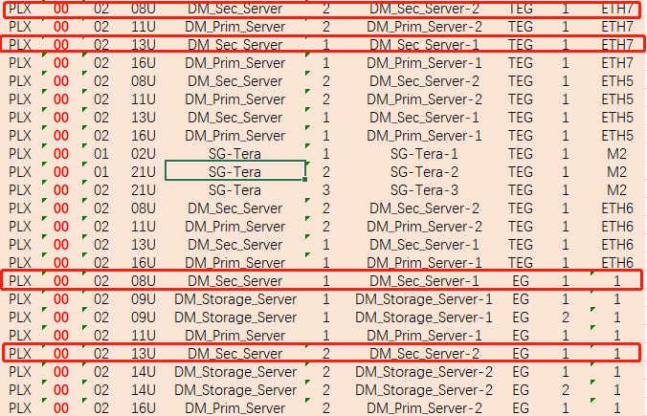
- 2机柜的交换机位置不对。
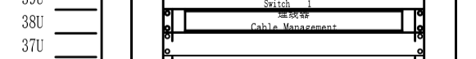
U37的位置什么也没有。
- 4机柜线表有问题。
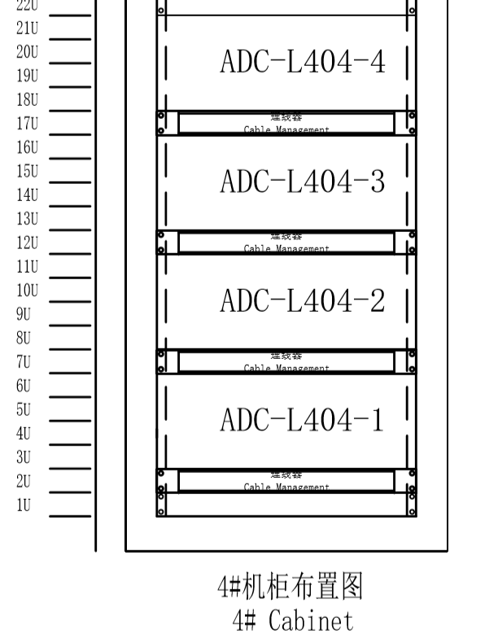
linux过滤结果。（过滤的4机柜）
PLX,00,04,03U,ADC-L404,01,ADC-L404-01,TEG,1,01
PLX,00,04,03U,ADC-L404,01,ADC-L404-01,TEG,1,02
PLX,00,04,03U,ADC-L404,01,ADC-L404-01,TEG,1,03
PLX,00,04,03U,ADC-L404,01,ADC-L404-01,TEG,1,04
PLX,00,04,03U,ADC-L404,01,ADC-L404-01,TEG,1,05
PLX,00,04,03U,ADC-L404,01,ADC-L404-01,TEG,1,06
PLX,00,04,03U,ADC-L404,01,ADC-L404-01,TEG,1,07
PLX,00,04,03U,ADC-L404,01,ADC-L404-01,TEG,1,08
PLX,00,04,03U,ADC-L404,01,ADC-L404-01,TEG,1,09
PLX,00,04,03U,ADC-L404,01,ADC-L404-01,TEG,1,10
PLX,00,04,03U,ADC-L404,01,ADC-L404-01,TEG,1,21
PLX,00,04,03U,ADC-L404,01,ADC-L404-01,TEG,1,22
PLX,00,04,03U,ADC-L404,05,ADC-L404-05,TEG,1,05
PLX,00,04,03U,ADC-L404,05,ADC-L404-05,TEG,1,06
PLX,00,04,03U,ADC-L404,05,ADC-L404-05,TEG,1,07
PLX,00,04,03U,ADC-L404,05,ADC-L404-05,TEG,1,08
PLX,00,04,03U,ADC-L404,05,ADC-L404-05,TEG,1,09
PLX,00,04,03U,ADC-L404,05,ADC-L404-05,TEG,1,10
PLX,00,04,03U,ADC-L404,09,ADC-L404-09,TEG,1,05
PLX,00,04,03U,ADC-L404,09,ADC-L404-09,TEG,1,06
PLX,00,04,03U,ADC-L404,09,ADC-L404-09,TEG,1,07
PLX,00,04,03U,ADC-L404,09,ADC-L404-09,TEG,1,08
PLX,00,04,03U,ADC-L404,09,ADC-L404-09,TEG,1,09
PLX,00,04,03U,ADC-L404,09,ADC-L404-09,TEG,1,10
PLX,00,04,03U,ADC-L404,13,ADC-L404-13,TEG,1,05
PLX,00,04,03U,ADC-L404,13,ADC-L404-13,TEG,1,06
PLX,00,04,03U,ADC-L404,13,ADC-L404-13,TEG,1,07
PLX,00,04,03U,ADC-L404,13,ADC-L404-13,TEG,1,08
PLX,00,04,03U,ADC-L404,13,ADC-L404-13,TEG,1,09
PLX,00,04,03U,ADC-L404,13,ADC-L404-13,TEG,1,10
PLX,00,04,08U,ADC-L404,02,ADC-L404-02,TEG,1,01
PLX,00,04,08U,ADC-L404,02,ADC-L404-02,TEG,1,02
PLX,00,04,08U,ADC-L404,02,ADC-L404-02,TEG,1,03
PLX,00,04,08U,ADC-L404,02,ADC-L404-02,TEG,1,04
PLX,00,04,08U,ADC-L404,02,ADC-L404-02,TEG,1,05
PLX,00,04,08U,ADC-L404,02,ADC-L404-02,TEG,1,06
PLX,00,04,08U,ADC-L404,02,ADC-L404-02,TEG,1,07
PLX,00,04,08U,ADC-L404,02,ADC-L404-02,TEG,1,08
PLX,00,04,08U,ADC-L404,02,ADC-L404-02,TEG,1,09
PLX,00,04,08U,ADC-L404,02,ADC-L404-02,TEG,1,10
PLX,00,04,08U,ADC-L404,02,ADC-L404-02,TEG,1,21
PLX,00,04,08U,ADC-L404,02,ADC-L404-02,TEG,1,22
PLX,00,04,08U,ADC-L404,06,ADC-L404-06,TEG,1,05
PLX,00,04,08U,ADC-L404,06,ADC-L404-06,TEG,1,06
PLX,00,04,08U,ADC-L404,06,ADC-L404-06,TEG,1,07
PLX,00,04,08U,ADC-L404,06,ADC-L404-06,TEG,1,08
PLX,00,04,08U,ADC-L404,06,ADC-L404-06,TEG,1,09
PLX,00,04,08U,ADC-L404,06,ADC-L404-06,TEG,1,10
PLX,00,04,08U,ADC-L404,10,ADC-L404-10,TEG,1,05
PLX,00,04,08U,ADC-L404,10,ADC-L404-10,TEG,1,06
PLX,00,04,08U,ADC-L404,10,ADC-L404-10,TEG,1,07
PLX,00,04,08U,ADC-L404,10,ADC-L404-10,TEG,1,08
PLX,00,04,08U,ADC-L404,10,ADC-L404-10,TEG,1,09
PLX,00,04,08U,ADC-L404,10,ADC-L404-10,TEG,1,10
PLX,00,04,08U,ADC-L404,14,ADC-L404-14,TEG,1,05
PLX,00,04,08U,ADC-L404,14,ADC-L404-14,TEG,1,06
PLX,00,04,08U,ADC-L404,14,ADC-L404-14,TEG,1,07
PLX,00,04,08U,ADC-L404,14,ADC-L404-14,TEG,1,08
PLX,00,04,08U,ADC-L404,14,ADC-L404-14,TEG,1,09
PLX,00,04,08U,ADC-L404,14,ADC-L404-14,TEG,1,10
PLX,00,04,13U,ADC-L404,03,ADC-L404-03,TEG,1,01
PLX,00,04,13U,ADC-L404,03,ADC-L404-03,TEG,1,02
PLX,00,04,13U,ADC-L404,03,ADC-L404-03,TEG,1,03
PLX,00,04,13U,ADC-L404,03,ADC-L404-03,TEG,1,04
PLX,00,04,13U,ADC-L404,03,ADC-L404-03,TEG,1,05
PLX,00,04,13U,ADC-L404,03,ADC-L404-03,TEG,1,06
PLX,00,04,13U,ADC-L404,03,ADC-L404-03,TEG,1,07
PLX,00,04,13U,ADC-L404,03,ADC-L404-03,TEG,1,08
PLX,00,04,13U,ADC-L404,03,ADC-L404-03,TEG,1,09
PLX,00,04,13U,ADC-L404,03,ADC-L404-03,TEG,1,10
PLX,00,04,13U,ADC-L404,03,ADC-L404-03,TEG,1,21
PLX,00,04,13U,ADC-L404,03,ADC-L404-03,TEG,1,22
PLX,00,04,13U,ADC-L404,07,ADC-L404-07,TEG,1,05
PLX,00,04,13U,ADC-L404,07,ADC-L404-07,TEG,1,06
PLX,00,04,13U,ADC-L404,07,ADC-L404-07,TEG,1,07
PLX,00,04,13U,ADC-L404,07,ADC-L404-07,TEG,1,08
PLX,00,04,13U,ADC-L404,07,ADC-L404-07,TEG,1,09
PLX,00,04,13U,ADC-L404,07,ADC-L404-07,TEG,1,10
PLX,00,04,13U,ADC-L404,11,ADC-L404-11,TEG,1,05
PLX,00,04,13U,ADC-L404,11,ADC-L404-11,TEG,1,06
PLX,00,04,13U,ADC-L404,11,ADC-L404-11,TEG,1,07
PLX,00,04,13U,ADC-L404,11,ADC-L404-11,TEG,1,08
PLX,00,04,13U,ADC-L404,11,ADC-L404-11,TEG,1,09
PLX,00,04,13U,ADC-L404,11,ADC-L404-11,TEG,1,10
PLX,00,04,18U,ADC-L404,04,ADC-L404-04,TEG,1,01
PLX,00,04,18U,ADC-L404,04,ADC-L404-04,TEG,1,02
PLX,00,04,18U,ADC-L404,04,ADC-L404-04,TEG,1,03
PLX,00,04,18U,ADC-L404,04,ADC-L404-04,TEG,1,04
PLX,00,04,18U,ADC-L404,04,ADC-L404-04,TEG,1,05
PLX,00,04,18U,ADC-L404,04,ADC-L404-04,TEG,1,06
PLX,00,04,18U,ADC-L404,04,ADC-L404-04,TEG,1,07
PLX,00,04,18U,ADC-L404,04,ADC-L404-04,TEG,1,08
PLX,00,04,18U,ADC-L404,04,ADC-L404-04,TEG,1,09
PLX,00,04,18U,ADC-L404,04,ADC-L404-04,TEG,1,10
PLX,00,04,18U,ADC-L404,04,ADC-L404-04,TEG,1,21
PLX,00,04,18U,ADC-L404,04,ADC-L404-04,TEG,1,22
PLX,00,04,18U,ADC-L404,08,ADC-L404-08,TEG,1,05
PLX,00,04,18U,ADC-L404,08,ADC-L404-08,TEG,1,06
PLX,00,04,18U,ADC-L404,08,ADC-L404-08,TEG,1,07
PLX,00,04,18U,ADC-L404,08,ADC-L404-08,TEG,1,08
PLX,00,04,18U,ADC-L404,08,ADC-L404-08,TEG,1,09
PLX,00,04,18U,ADC-L404,08,ADC-L404-08,TEG,1,10
PLX,00,04,18U,ADC-L404,12,ADC-L404-12,TEG,1,05
PLX,00,04,18U,ADC-L404,12,ADC-L404-12,TEG,1,06
PLX,00,04,18U,ADC-L404,12,ADC-L404-12,TEG,1,07
PLX,00,04,18U,ADC-L404,12,ADC-L404-12,TEG,1,08
PLX,00,04,18U,ADC-L404,12,ADC-L404-12,TEG,1,09
PLX,00,04,18U,ADC-L404,12,ADC-L404-12,TEG,1,10

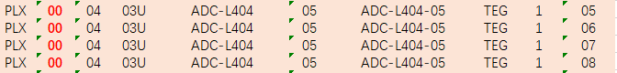
4机柜的3U位置只有ADC-l404-01设备。
线表中4机柜3U的位置却有ADC-l404-01、ADC-l404-05、ADC-l404-09、ADC-l404-13的设备连接端口。

- 8机柜2U位置5板卡需要确定。
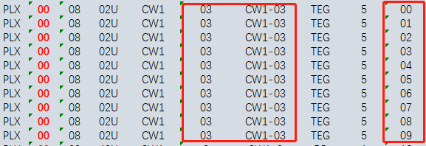
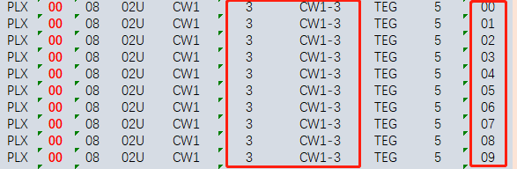
确定设备序号和设备编号03和3有区别么？
如果没有却别的话00-09的端口就重了。

- 11机柜的2U位置和4U位置端口重复了。
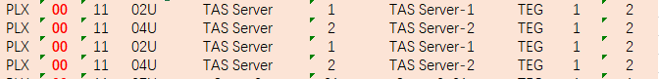

- 12机柜的系统图中没有29U和40U位置的设备。
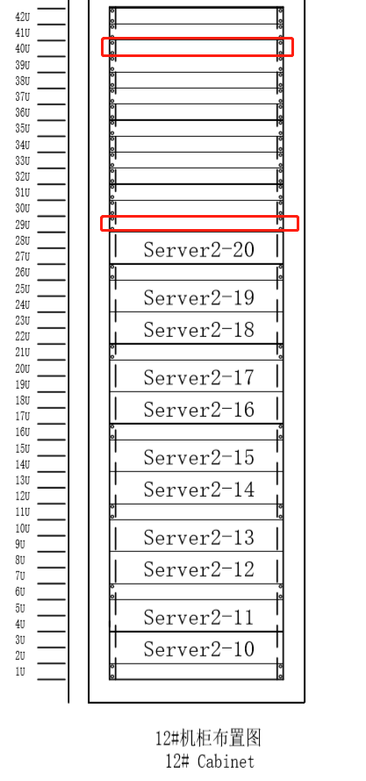
线表中有：

- 13机柜的server彻底乱了。
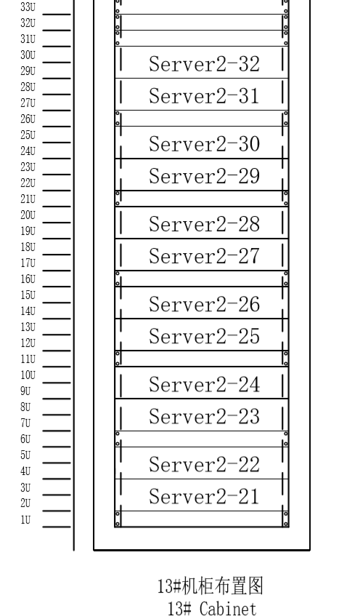
线表：
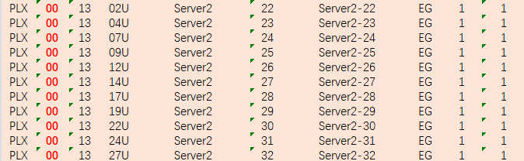
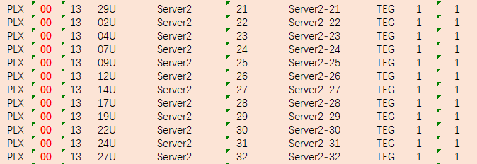
系统图和线表的位置乱了。

- 14机柜的27U和29U位置没有server-31和server-32设备。

