设备管理部署

1.1参考网站
https://docs.geedge.net/pages/viewpage.action?pageId=2819196

1.2安装前注意事项
1． 部署目的设备只能是ADC
2. 所有服务器都必须修改hostname（全网唯一，可参考其他机器）
3. 时钟同步
4. 确认部署环境，确认ADC计算板0是否已经存在Mariadb

1.3配置文件模板说明

1.3.1配置文件路径
../device-management-scripts/install_config/group_vars/all.yml

1.3.2配置文件说明
#Grafana配置项，默认端口53000，无需更改
grafana:
http_port: 53000

#InfluxDB配置项
influxdb:
cluster_ip: "192.168.40.210" #设备管理集群端IP地址
dbname: tsg_stat #库名（默认配置，无需更改）
username: admin #用户名（默认配置，无需更改）
passwd: tsg2019 #密码（默认配置，无需更改）
meta_dir: /var/lib/influxdb/meta #元数据存储路径（默认配置，无需更改）
data_dir: /var/lib/influxdb/data #最终数据存储路径（默认配置，无需更改）
wal_dir: /var/lib/influxdb/wal-dir #存放预写日志文件存储路径（默认配置，无需更改）

#Conusl配置项
consul:
datacenter: consul-xxg #数据中心名称，需按照规划定义
dckey: "XwXLAbVN1C44dLUVJ6UL5A==" #数据中心唯一key，可进入./bin/目录执行consul keygen
cluster_ip: "192.168.40.210" #设备管理集群端IP地址
cluster_ethname: ens33 #集群端服务器管理口网卡名
external_ethname: enp2s0 #ADC交换板管理口网卡名
mcn01_internal_ethname: enp7s0 #ADC计算板日志传输网卡名
mcn23_internal_ethname: enp7s0

#MariaDB配置项
mariadb:
username: root #用户名（默认配置，无需更改）
password: 111111 #密码（默认配置，无需更改）
cluster_ip: "192.168.40.210" #MariaDB地址，此地址为bifang-mariadb所在地址

#OAM配置项
oam:
snmptrapd_ip: "192.168.40.175"
snmptrapd_port: 162

java_version: jdk1.8.0_73 #JDK版本
bifang_api_ip: "192.168.40.4" #bifang-api地址，此地址xxg环境为40.4

hosts文件说明
[all:vars]
ansible_user=root
use_chassis_hardware_sn=false #如果使用SN编码，则此配置应为false关闭，否则使用true打开，设备编码由硬件配置自定义
rpm_file_name=tsg-cli-1.0.14.eccfd07-1.el7.x86_64.rpm

#[cluster_server]
#192.168.40.210 influxdb_cluster=true #集群端host，influxdb_cluster必须为true

[blade-mxn]
192.168.40.175 SN=CBT2201925000004 mcn0_ip=192.168.40.171
#ADC交换板host，SN按照格式可自行编辑，每个交换板host后需要写本机mcn0的日志传输IP地址

[blade-mcn0]
192.168.40.171 SN=CBT2201925000004 server_ip=192.168.40.175
#server_ip即本机交换板管理口地址

[blade-mcn1]
192.168.40.172 SN=CBT2201925000004 server_ip=192.168.40.175
[blade-mcn2]
暂时无此设备
[blade-mcn3]
192.168.40.174 SN=CBT2201925000004 server_ip=192.168.40.175

deploy.yml文件说明
注意：默认配置中，集群端相关的安装和mcn0上MariaDB的安装都注释了。在生产环境中，首先要确认mcn0上是否已经安装MariaDB（如：用再生龙给ADC灌系统，则MariaDB已经安装），若重复安装可能会造成MariaDB异常的情况。集群端软件同理，若环境为首次部署需要打开集群端安装的注释符，若为扩容，则不可安装。
- hosts: all
roles:
- jdk1.8.0_73 #java –version查看版本号,根据版本决定是否安装

- hosts: cluster_server
roles:
#- consul-cluster
#- mariadb
#- influxdb

- hosts: blade-mxn
roles:
- consul-external
- tsg-cli-mxn
- oam_cli_agent_mxn
- oam_cli
- oam_core
- oam_snmp
#- ipython #暂时禁掉，安装的时候有报错

- hosts: blade-mcn0
roles:
- consul-internal_mcn01
- telegraf
- influxdb
- grafana
- tsg-cli-mcn0
#- mariadb
- oam_cli_agent

- hosts: blade-mcn1
roles:
- consul-internal_mcn01
- tsg-cli-mcn1
- oam_cli_agent

- hosts: blade-mcn2
roles:
- consul-internal_mcn23
- tsg-cli-mcn2
- oam_cli_agent

- hosts: blade-mcn3
roles:
- consul-internal_mcn23
- tsg-cli-mcn3
- oam_cli_agent

- hosts: blade-mxn
roles:
- oam_mxn_start

- hosts: cluster_server
roles:
#- oam_cluster

1.4一键安装
ansible-playbook -i install_config/ deploy.yml

1.5部署后检查及效果验证

1.5.1检查consul
1.在任意consul节点执行consul members 检查consul状态
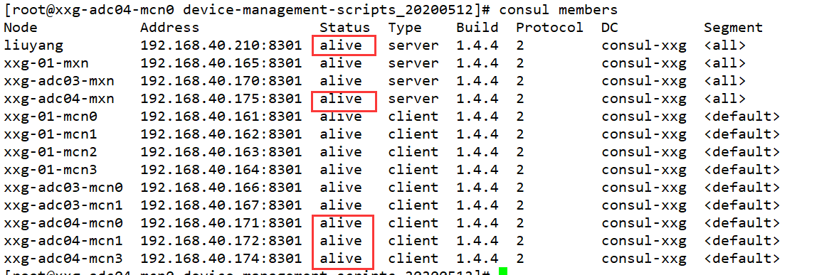
2.登录consul UI界面，地址: 集群端IP地址:8500，查看consul kv中是否已经注册设备（部署时hosts中填入的SN码）
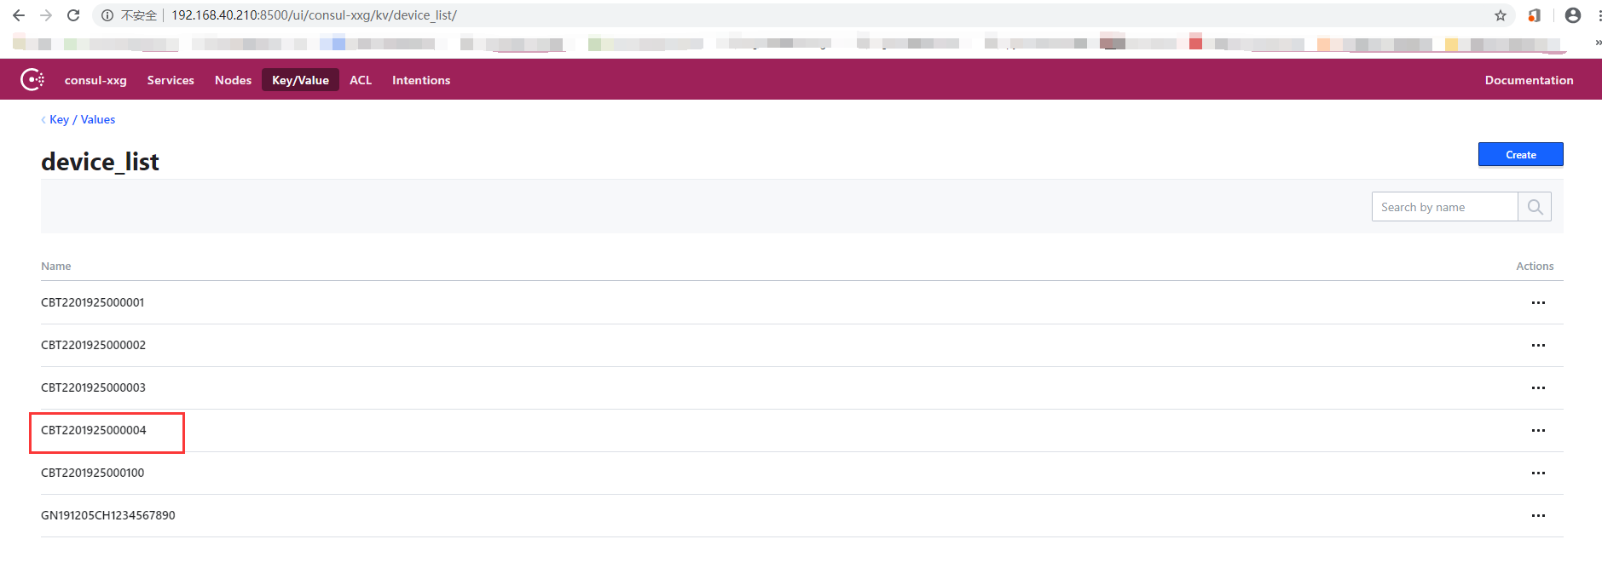

1.5.2 执行诊断进程检查状态
1.登入ADC交换板，进入/opt/tsg/bin目录，执行tsg_diagnose
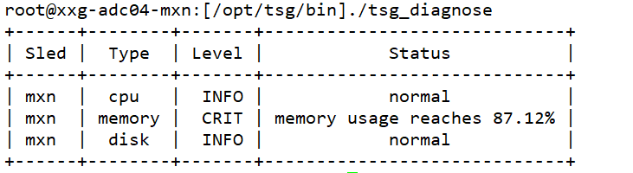
正常情况下，Status状态了会显示为normal，如果出现error，则表示异常，通常情况下需要检查交换板上的oam_core是否正常
OAM异常情况
1）集群端或mcn0上的MariaDB不正常，主要包括：用户名密码设置错误、MariaDB未启动、MariaDB没有远程权限
2）oam_cli_agent_mxn未启动
3）查看库tsg_oam是否安装（如果不是用ansible安装的一定要看下）

1.5.3界面device list验证
1.登录bifang界面后，查看主页目前注册的设备总量，是否和部署设备管理的设备总量一致
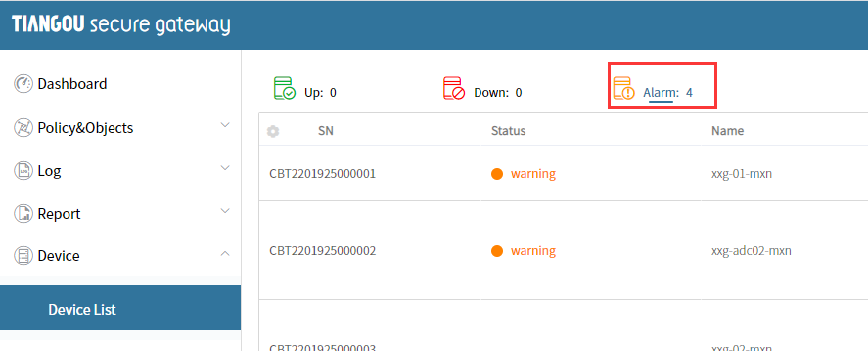
2.点击左侧菜单栏的Device List进入设备管理界面
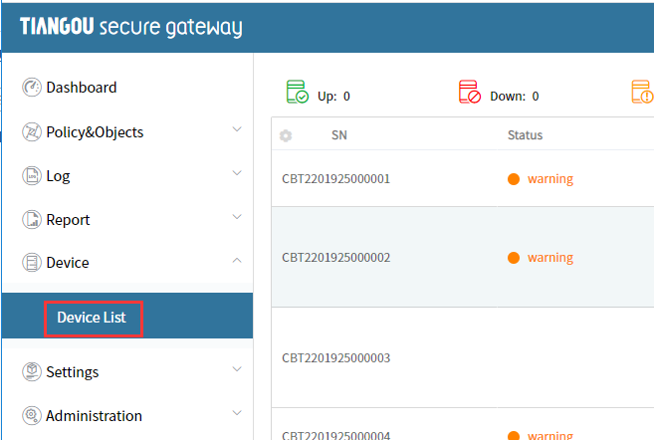
3.已注册设备列表
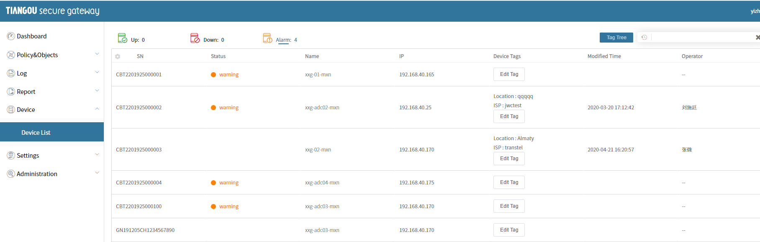
4.点击其中一个设备，可查看详细采集信息
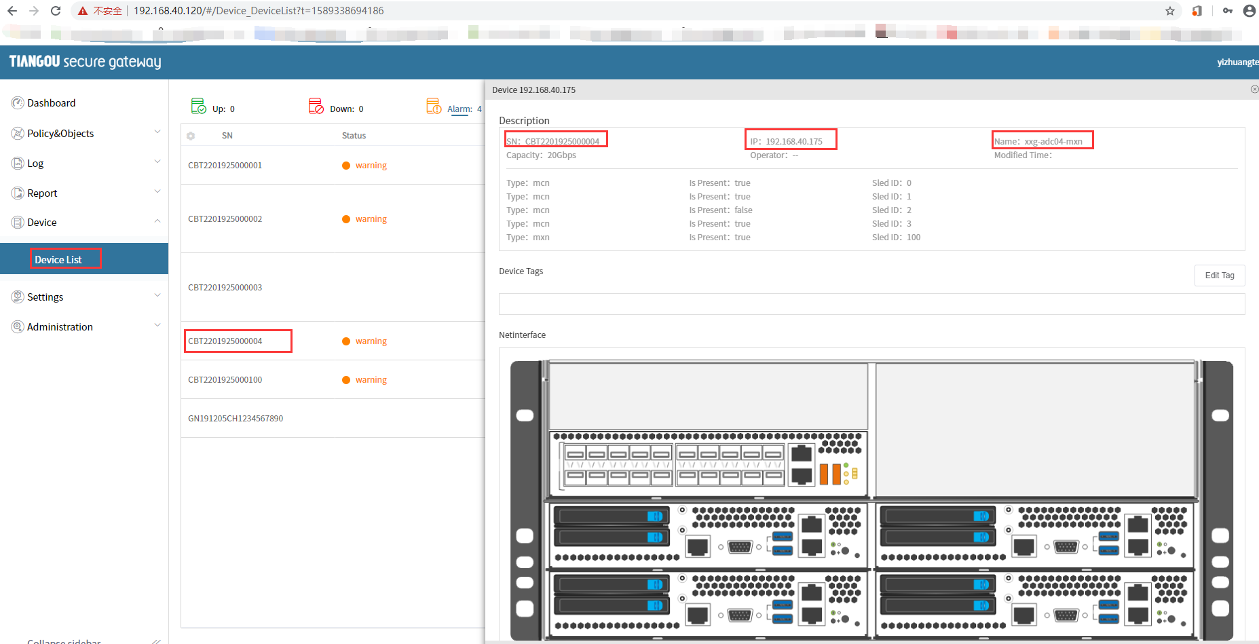
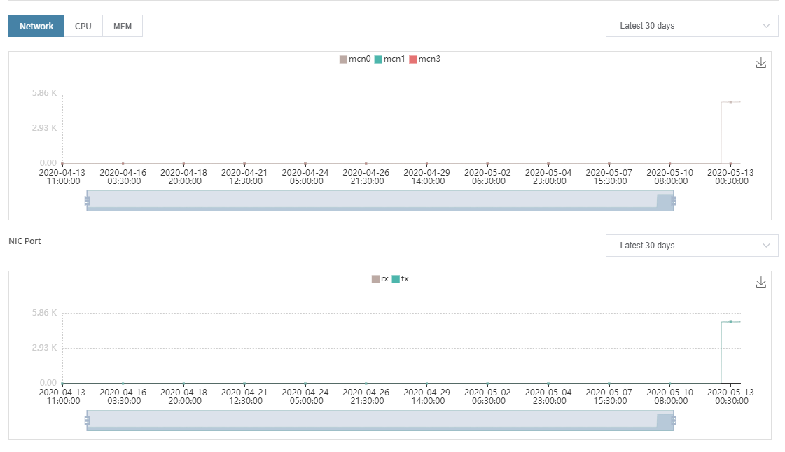
5.下图中数据记录在InfluxDB中
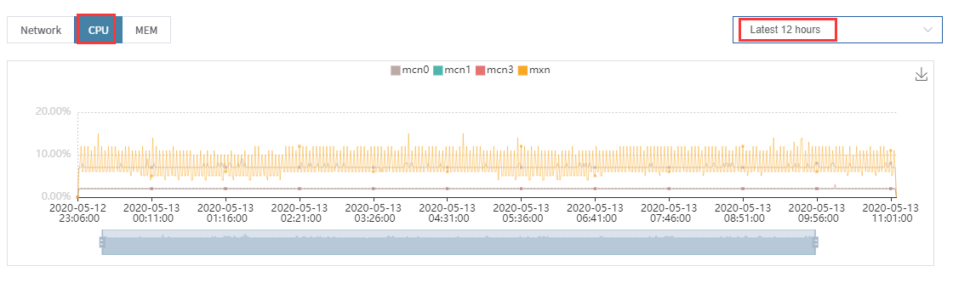

1.5.4 oam_snmp验证
1.运行状态检查
Systemctl status oam_snmp
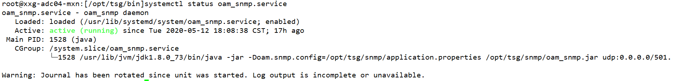
2.snmpwalk命令效果验证
正常情况下无报错，能展示各项参数数值，如报错timeout，应检查交换板/etc/snmp/snmpd.conf和部署脚本中的配置文件是否一致
snmpwalk v3 命令
snmpwalk -v 3 -u SHA -a SHA -A SHAAuthPP (交换板管理口IP地址):50161 1.3.6.1.4.1.54450
root@xxg-adc04-mxn:[/opt/tsg/bin]snmpwalk -v 3 -u SHA -a SHA -A SHAAuthPP 192.168.40.175:50161 1.3.6.1.4.1.54450
MIB search path: /root/.snmp/mibs:/usr/share/snmp/mibs
Cannot find module (adsn): At line 12 in /usr/share/snmp/mibs/adsnVlan-MIB.txt
Cannot find module (adsn): At line 12 in /usr/share/snmp/mibs/adsnTrunk-MIB.txt
Cannot find module (adsn): At line 12 in /usr/share/snmp/mibs/adsnQosDiff-MIB.txt
Cannot find module (adsn): At line 12 in /usr/share/snmp/mibs/adsnPort-MIB.txt
Cannot find module (adsn): At line 12 in /usr/share/snmp/mibs/adsnRoute-MIB.txt
Cannot find module (adsn): At line 12 in /usr/share/snmp/mibs/adsnL2-MIB.txt
Cannot find module (adsn): At line 12 in /usr/share/snmp/mibs/adsnRouteIpv6-MIB.txt
Cannot find module (adsn): At line 12 in /usr/share/snmp/mibs/adsnCos-MIB.txt
Cannot find module (adsn): At line 12 in /usr/share/snmp/mibs/adsnAcl-MIB.txt
SNMPv2-SMI::enterprises.54450.1.1.0 = INTEGER: 51
SNMPv2-SMI::enterprises.54450.1.2.0 = INTEGER: 50
SNMPv2-SMI::enterprises.54450.1.3.0 = INTEGER: 38
SNMPv2-SMI::enterprises.54450.1.4.0 = STRING: "0.99"
SNMPv2-SMI::enterprises.54450.1.5.0 = STRING: "0.87"
SNMPv2-SMI::enterprises.54450.1.6.0 = STRING: "0.87"
SNMPv2-SMI::enterprises.54450.1.7.0 = STRING: "3.3"
SNMPv2-SMI::enterprises.54450.1.8.0 = STRING: "4.967"
snmpwalk v2 命令
snmpwalk -v 2c -c public (交换板管理口IP地址):50161 1.3.6.1.4.1.54450
root@xxg-adc04-mxn:[/opt/tsg/bin]snmpwalk -v 2c -c public 192.168.40.175:50161 1.3.6.1.4.1.54450
MIB search path: /root/.snmp/mibs:/usr/share/snmp/mibs
Cannot find module (adsn): At line 12 in /usr/share/snmp/mibs/adsnVlan-MIB.txt
Cannot find module (adsn): At line 12 in /usr/share/snmp/mibs/adsnTrunk-MIB.txt
Cannot find module (adsn): At line 12 in /usr/share/snmp/mibs/adsnQosDiff-MIB.txt
Cannot find module (adsn): At line 12 in /usr/share/snmp/mibs/adsnPort-MIB.txt
Cannot find module (adsn): At line 12 in /usr/share/snmp/mibs/adsnRoute-MIB.txt
Cannot find module (adsn): At line 12 in /usr/share/snmp/mibs/adsnL2-MIB.txt
Cannot find module (adsn): At line 12 in /usr/share/snmp/mibs/adsnRouteIpv6-MIB.txt
Cannot find module (adsn): At line 12 in /usr/share/snmp/mibs/adsnCos-MIB.txt
Cannot find module (adsn): At line 12 in /usr/share/snmp/mibs/adsnAcl-MIB.txt
SNMPv2-SMI::enterprises.54450.1.1.0 = INTEGER: 51
SNMPv2-SMI::enterprises.54450.1.2.0 = INTEGER: 50
SNMPv2-SMI::enterprises.54450.1.3.0 = INTEGER: 38
SNMPv2-SMI::enterprises.54450.1.4.0 = STRING: "0.99"
SNMPv2-SMI::enterprises.54450.1.5.0 = STRING: "0.87"
SNMPv2-SMI::enterprises.54450.1.6.0 = STRING: "0.87"
SNMPv2-SMI::enterprises.54450.1.7.0 = STRING: "3.3"
SNMPv2-SMI::enterprises.54450.1.8.0 = STRING: "4.967"

1.5.5 snmptrap验证
1.snmptrap命令主要用途是通过snmp向指定服务器发送消息，oam_core会调用snmptrap命令向指定服务器发送ADC设备产生的告警信息
root@xxg-adc04-mxn:[/opt/tsg/bin]snmpwalk -v 3 -u SHA -a SHA -A SHAAuthPP 192.168.40.175:50161 .1.3.6.1.4.1.54450
MIB search path: /root/.snmp/mibs:/usr/share/snmp/mibs
Cannot find module (adsn): At line 12 in /usr/share/snmp/mibs/adsnVlan-MIB.txt
Cannot find module (adsn): At line 12 in /usr/share/snmp/mibs/adsnTrunk-MIB.txt
Cannot find module (adsn): At line 12 in /usr/share/snmp/mibs/adsnQosDiff-MIB.txt
Cannot find module (adsn): At line 12 in /usr/share/snmp/mibs/adsnPort-MIB.txt
Cannot find module (adsn): At line 12 in /usr/share/snmp/mibs/adsnRoute-MIB.txt
Cannot find module (adsn): At line 12 in /usr/share/snmp/mibs/adsnL2-MIB.txt
Cannot find module (adsn): At line 12 in /usr/share/snmp/mibs/adsnRouteIpv6-MIB.txt
Cannot find module (adsn): At line 12 in /usr/share/snmp/mibs/adsnCos-MIB.txt
Cannot find module (adsn): At line 12 in /usr/share/snmp/mibs/adsnAcl-MIB.txt
SNMPv2-SMI::enterprises.54450.1.1.0 = INTEGER: 51
SNMPv2-SMI::enterprises.54450.1.2.0 = INTEGER: 50
SNMPv2-SMI::enterprises.54450.1.3.0 = INTEGER: 38
SNMPv2-SMI::enterprises.54450.1.4.0 = STRING: "0.99"
SNMPv2-SMI::enterprises.54450.1.5.0 = STRING: "0.87"
2.下列说明为验证部署后设备是否具有snmptrap的基础功能
在交换板上执行命令，前台查看snmptrap消息
snmptrapd -f -C -c /etc/snmp/snmptrapd.conf -Le
另起窗口，执行命令手动trap消息
snmptrap -v 2c -c public 10.3.58.1 "" 1.3.6.1.4.1.2345 .1.3.6.1.4.1.54450.15.1 s "TTTTTTTTTEST"
3.检查是否收到命令，收到则表示snmptrap功能正常

1.5.6 tsg_cli验证
登录
ssh登录tsg_cli命令行界面，用户名tsgadmin，密码Cli2019
执行命令查询help
tsg_policy --help
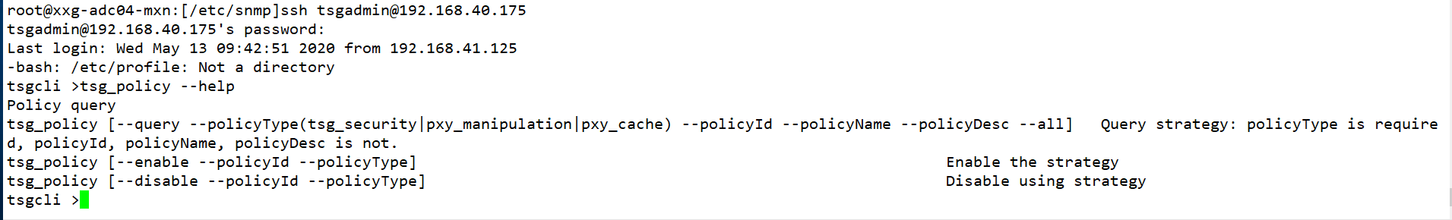
查询security策略
tsg_policy --query --policyType tsg_security
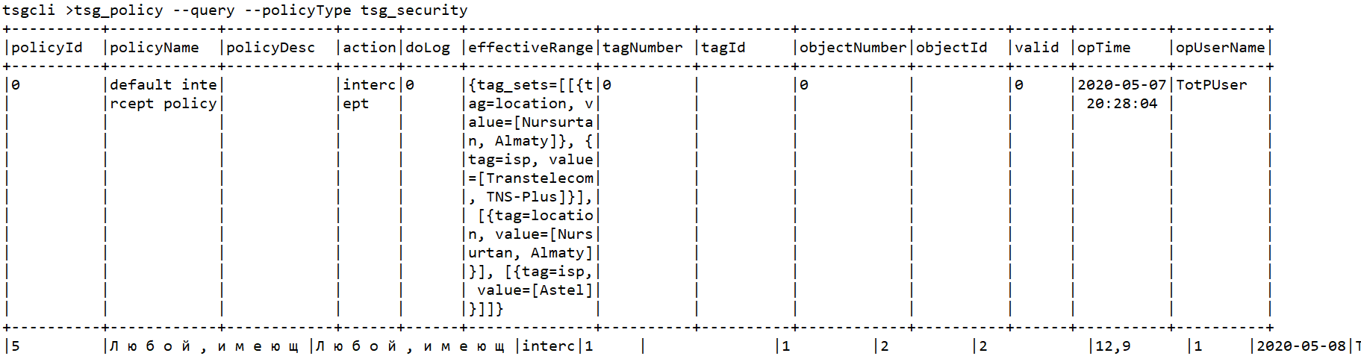

1.6设备管理验证报错总结

1.6.1诊断进程检查状态
1.登入ADC交换板，进入/opt/tsg/bin目录，执行tsg_diagnose
root@xxg-adc04-mxn:[/opt/tsg/bin]./tsg_diagnose
+------+--------+-------+----------------------+
| Sled | Type | Level | Status |
+------+--------+-------+----------------------+
| mxn | cpu | ERR | No recent statistics |
| mxn | memory | ERR | No recent statistics |
| mxn | disk | INFO | normal |
+------+--------+-------+----------------------+
2.检查用户名和密码，mariadb是否启动，mariadb有没有远程权限，oam_cli_agent_mxn未启动
update user set host = '%' where user = 'root';
grant all privileges on *.* to root@'%' identified by "111111";
flush privileges;
create database tsg_oam
flush privileges;
3.验证mariadb是否可以远程登录
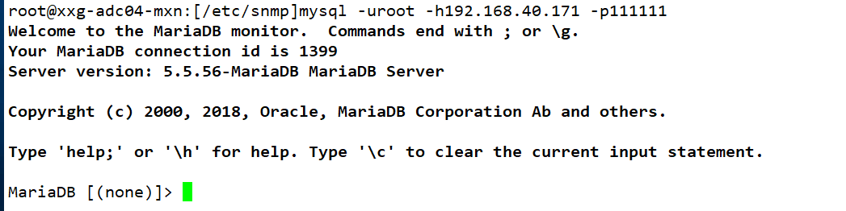
4.重新验证tsg_diagnose,成功
root@xxg-adc04-mxn:[/opt/tsg/bin]./tsg_diagnose
+------+--------+-------+-----------------------------+
| Sled | Type | Level | Status |
+------+--------+-------+-----------------------------+
| mxn | cpu | INFO | normal |
| mxn | memory | CRIT | memory usage reaches 88.58% |
| mxn | disk | INFO | normal |
+------+--------+-------+-----------------------------+

1.6.2snmpwalk命令效果验证
snmpwalk -v 3 -u SHA -a SHA -A SHAAuthPP (交换板管理口IP地址):50161 1.3.6.1.4.1.54450
snmpwalk -v 2c -c public (交换板管理口IP地址):50161 1.3.6.1.4.1.54450
1.有提示报错timeout
2.检查原因，snmptrapd.conf没有加执行权限，添加执行权限
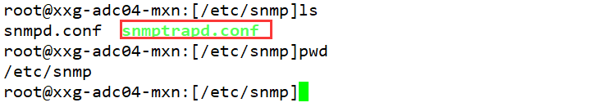
3.重新验证成功
root@xxg-adc04-mxn:[/etc/snmp]snmpwalk -v 3 -u SHA -a SHA -A SHAAuthPP 192.168.40.175:50161 1.3.6.1.4.1.54450
MIB search path: /root/.snmp/mibs:/usr/share/snmp/mibs
Cannot find module (adsn): At line 12 in /usr/share/snmp/mibs/adsnVlan-MIB.txt
Cannot find module (adsn): At line 12 in /usr/share/snmp/mibs/adsnTrunk-MIB.txt
Cannot find module (adsn): At line 12 in /usr/share/snmp/mibs/adsnQosDiff-MIB.txt
Cannot find module (adsn): At line 12 in /usr/share/snmp/mibs/adsnPort-MIB.txt
Cannot find module (adsn): At line 12 in /usr/share/snmp/mibs/adsnRoute-MIB.txt
Cannot find module (adsn): At line 12 in /usr/share/snmp/mibs/adsnL2-MIB.txt
Cannot find module (adsn): At line 12 in /usr/share/snmp/mibs/adsnRouteIpv6-MIB.txt
Cannot find module (adsn): At line 12 in /usr/share/snmp/mibs/adsnCos-MIB.txt
Cannot find module (adsn): At line 12 in /usr/share/snmp/mibs/adsnAcl-MIB.txt
SNMPv2-SMI::enterprises.54450.1.1.0 = INTEGER: 51
SNMPv2-SMI::enterprises.54450.1.2.0 = INTEGER: 50
SNMPv2-SMI::enterprises.54450.1.3.0 = INTEGER: 38
SNMPv2-SMI::enterprises.54450.1.4.0 = STRING: "0.99"
SNMPv2-SMI::enterprises.54450.1.5.0 = STRING: "0.87"
SNMPv2-SMI::enterprises.54450.1.6.0 = STRING: "0.87"

1.6.3查询security策略
1.执行下面语句，报错404
tsg_policy --query --policyType tsg_security
2.检查原因，端口错误
/opt/tsg/cli/application.properties
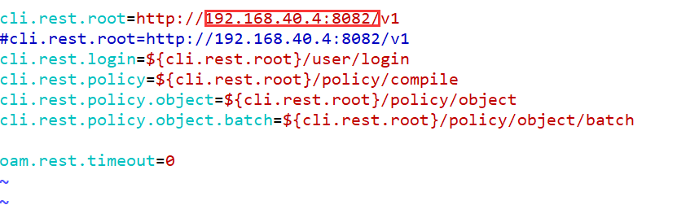
3.重新验证，ssh登录tsg_cli命令行界面，用户名tsgadmin，密码Cli2019

1.7注意
1.influxdb和mariadb都写成192.168.100.1
