portal+radius测试部署

实验一：openportal（免费版）+radius搭建
实验目的：测试机通过openportal申请访问互联网，用户需要通过界面认证radius提前预设的用户名及密码，认证成功后自动跳转web界面，才可以成功放问互联网。

实验拓扑

实现流程
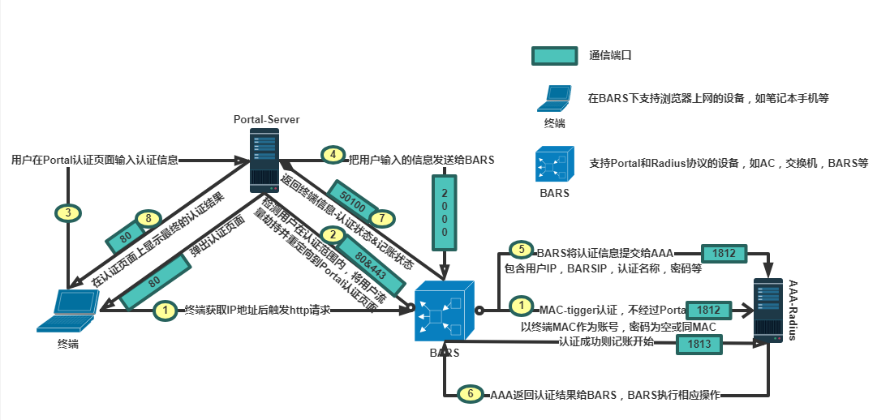

Portal认证的基本过程是：客户机首先通过DHCP协议获取到IP地址（也可以使用静态IP地址），但是客户使用获取到的IP地址并不能登上Internet，在认证通过前只能访问特定的IP地址，这个地址通常是PORTAL服务器的IP地址。采用Portal认证的接入设备必须具备这个能力。一般通过修改接入设备的访问控制表（ACL）可以做到。
用户登录到Portal Server后，可以浏览上面的内容，比如广告、新闻等免费信息，同时用户还可以在网页上输入用户名和密码，它们会被WEB客户端应用程序传给 Portal Server，再由Portal Server与NAS之间交互来实现用户的认证。
Portal Server在获得用户的用户名和密码外，还会得到用户的IP地址，以它为索引来标识用户。然后Portal Server 与NAS之间用Portal协议直接通信，而NAS又与RADIUS 服务器直接通信完成用户的认证和上线过程。因为安全问题，通常支持安全性较强的CHAP式认证。

实验环境
交换机：s5720
操作系统：centos7.4-minimal.iso,win10

实验过程

步骤一：部署openportal
软件包名：
jdk-7u79-linux-x64.rpm
OpenPortalServer V3.10.0.0 2017-07-01.zip
安装所需软件：
rpm -ivh jdk-7u79-linux-x64.rpm
yum install -y mysql-server mysql mysql-deve
yum -y install unzip dmidecode
yum -y install expect*

设置mysql开机启动
chkconfig mysqld on
Systemctl mysqld start

配置对接sql密码
sed-i"6cjdbc1.password=portal1230" /usr/openportal/webapps/ROOT/WEB-INF/classes/properties/jdbc.properties

初始化
mysql_secure_installation
重新设置密码为protal1230

导入openportal数据表
mysqladmin -u root password protal1230

use mysql;
update user set password=password('111111') where user='root';
GRANT ALL PRIVILEGES ON *.* TO 'root'@'%' IDENTIFIED BY '111111' WITH GRANT OPTION;
flush privileges;
CREATE DATABASE openportalserver DEFAULT CHARACTER SET utf8 COLLATE utf8_general_ci;
exit;

mysql -u root -p openportalserver < /usr/openportal/OpenPortalServer.sql
输入密码protal1230

Systemctl mysqld restart

chmod 777 /usr/openportal/bin/*

写入开机自启
echo "JAVA_HOME=/usr/java/jdk1.7.0_79" >>/etc/profile
echo "JRE_HOME=/usr/java/jdk1.7.0_79/jre" >>/etc/profile
echo "PATH=$PATH:$JAVA_HOME/bin:$JRE_HOME/bin" >>/etc/profile
echo "CLASSPATH=.:$JAVA_HOME/lib/dt.jar:$JAVA_HOME/lib/tools.jar:$JRE_HOME/lib" >>/etc/profile
echo "export JAVA_HOME JRE_HOME PATH CLASSPATH" >>/etc/profile
source /etc/profile
echo "source /etc/profile" >>/etc/rc.d/rc.local
echo "/usr/openportal/bin/startup.sh" >>/etc/rc.d/rc.local

./startup.sh

tail -f /usr/openportal/logs/catalina.out

访问192.168.41.202
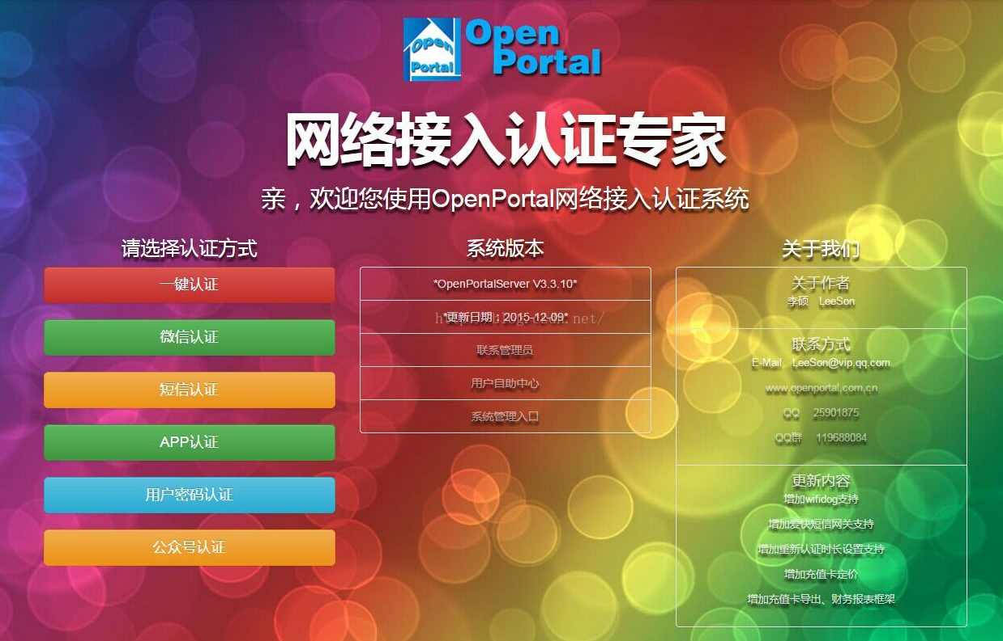

步骤二：部署freeradius
软件包：
freeradius-3.0.13-6.el7.x86_64

yum install freeradius freeradius-utils（可使用阿里yum源）

编辑/etc/raddb/users文件，取消测试用户相关信息的注释
sed -i '73,81s/^#//g' /etc/raddb/users

radius -X启动

radtest steve testing localhost 0 testing123测试命令
如果输出"Access-Accept packet" 表示成功了，"Access-Reject" 表示失败了。

创建radius表
create database radius;

配置freeradius对接数据库
cd /etc/raddb/mods-config/sql/main/mysql
cp setup.sql setup.sql.ori
egrep -v '^$|#' setup.sql.ori > setup.sql

CREATE USER 'radius'@'localhost';
SET PASSWORD FOR 'radius'@'localhost' = PASSWORD('radpass');
GRANT SELECT ON radius.* TO 'radius'@'localhost';
GRANT ALL on radius.radacct TO 'radius'@'localhost';
GRANT ALL on radius.radpostauth TO 'radius'@'localhost';

创建radius用户
source /etc/raddb/mods-config/sql/main/mysql/setup.sql;
use radius;
source /etc/raddb/mods-config/sql/main/mysql/schema.sql;

启用sql模块
ln -s /etc/raddb/mods-available/sql /etc/raddb/mods-enabled/
sed -i '31s/"rlm_sql_null"/"rlm_sql_mysql"/g' /etc/raddb/mods-enabled/sql
sed -i '87s/"sqlite"/"mysql"/g' /etc/raddb/mods-enabled/sql
sed -i '91,94s/#///g' /etc/raddb/mods-enabled/sql
sed -i '/read_clients = yes/s/#//g' /etc/raddb/mods-enabled/sql

chgrp -h radiusd /etc/raddb/mods-enabled/sql

添加开机启动
systemctl daemod-reload
systemctl enable mariadb.service
systemctl enable radiusd.service
sed-i'3aAfter=mariadb.service' /etc/systemd/system/multi-user.target.wants/radiusd.service

添加客户端
cp /etc/raddb/clients.conf /etc/raddb/clients.conf.ori
egrep -v '^$|#' /etc/raddb/clients.conf.ori > /etc/raddb/clients.conf

添加用户组
use radius
insert into radgroupreply (groupname,attribute,op,value) values ('user','Auth-Type',':=','Local');
insert into radgroupreply (groupname,attribute,op,value) values ('user','Service-Type',':=','Framed-User');
insert into radgroupreply (groupname,attribute,op,value) values ('user','Framed-IP-Address',':=','255.255.255.255');
insert into radgroupreply (groupname,attribute,op,value) values ('user','Framed-IP-Netmask',':=','255.255.255.0');

添加用户
insert into radcheck (username,attribute,op,value) values ('pc','Cleartext-Password',':=','111111');

insert into radusergroup (username,groupname) values ('pc','user');

测试命令radtest test testpwd localhost 1812 testing123

添加以下内容，client为可访问段，密钥为交换机radius模板密码
Vim /etc/raddb/clients.conf
client 192.168.41.0/21 {
secret = aaa
}

注：如连接ac后updatesql错误，请添加
连接ac后报错，在mysql中添加
use radius;
DROP TABLE radacct;
CREATE TABLE radacct (
radacctid bigint(21) NOT NULL auto_increment,
acctsessionid varchar(64) NOT NULL default '',
acctuniqueid varchar(32) NOT NULL default '',
username varchar(64) NOT NULL default '',
groupname varchar(64) NOT NULL default '',
realm varchar(64) default '',
nasipaddress varchar(15) NOT NULL default '',
nasportid varchar(15) default NULL,
nasporttype varchar(32) default NULL,
acctstarttime datetime NULL default NULL,
acctupdatetime datetime NULL default NULL,
acctstoptime datetime NULL default NULL,
acctinterval int(12) default NULL,
acctsessiontime int(12) unsigned default NULL,
acctauthentic varchar(32) default NULL,
connectinfo_start varchar(50) default NULL,
connectinfo_stop varchar(50) default NULL,
acctinputoctets bigint(20) default NULL,
acctoutputoctets bigint(20) default NULL,
calledstationid varchar(50) NOT NULL default '',
callingstationid varchar(50) NOT NULL default '',
acctterminatecause varchar(32) NOT NULL default '',
servicetype varchar(32) default NULL,
framedprotocol varchar(32) default NULL,
framedipaddress varchar(15) NOT NULL default '',
PRIMARY KEY (radacctid),
UNIQUE KEY acctuniqueid (acctuniqueid),
KEY username (username),
KEY framedipaddress (framedipaddress),
KEY acctsessionid (acctsessionid),
KEY acctsessiontime (acctsessiontime),
KEY acctstarttime (acctstarttime),
KEY acctinterval (acctinterval),
KEY acctstoptime (acctstoptime),
KEY nasipaddress (nasipaddress)
) ENGINE = INNODB;

步骤三：配置华为s5720

配置文件:

[HUAWEI]display current-configuration
!Software Version V200R010C00SPC600
#
sysname HUAWEI
#
vlan batch 10
#
undo authentication unified-mode
#
dhcp enable
#
diffserv domain default
#
radius-server template default
radius-server template portal
radius-server shared-key cipher %^%#l!:6Z<~de1#h*t5(d(n$qs.b2<kaUX+lo@F`Q5)Z%^%#
radius-server authentication 192.168.41.202 1812 weight 80
radius-server accounting 192.168.41.202 1813 weight 80
undo radius-server user-name domain-included
radius-attribute nas-ip 192.168.41.200
radius-server authorization 192.168.41.202 shared-key cipher %^%#N8)~,H+24X.s]q%ehShTeB^I)fSSh;Bh[[/njxo=%^%#
#
url-template name portal
url http://192.168.41.202
url-parameter user-mac mac user-ipaddress wlanuserip sysname nasname redirect-url url
url-parameter mac-address format delimiter : normal
#
web-auth-server portal
server-ip 192.168.41.202
port 50100
shared-key cipher %^%#[nR];)YG/<>CnI-FU&eP*aSq&_14"M8Y<&C}ziG#%^%#
url-template portal
source-ip 192.168.41.200
#
drop-profile default
#
aaa
authentication-scheme default
authentication-scheme radius
authentication-mode radius
authorization-scheme default
accounting-scheme default
accounting-scheme radius
accounting-mode radius
accounting realtime 6
local-aaa-user password policy administrator
password expire 0
domain default
authentication-scheme default
radius-server default
domain default_admin
authentication-scheme default
domain portal
authentication-scheme radius
accounting-scheme radius
radius-server portal
local-user admin password irreversible-cipher $1a$oBl4BP$T-3$Eni|@RlB!WV+OE4x!&nLViI<4/vs'G5=piPlx*(U$
local-user admin privilege level 15
local-user admin service-type telnet terminal http
#
interface Vlanif1
#
interface Vlanif10
ip address 192.168.41.200 255.255.248.0
web-auth-server portal direct
portal domain portal
dhcp select relay
dhcp relay server-ip 192.168.41.1
#
interface MEth0/0/1
#
interface GigabitEthernet0/0/1
#
interface GigabitEthernet0/0/2
#
interface GigabitEthernet0/0/3
#
interface GigabitEthernet0/0/4
#
interface GigabitEthernet0/0/5
#
interface GigabitEthernet0/0/6
#
interface GigabitEthernet0/0/7
#
interface GigabitEthernet0/0/8
#
interface GigabitEthernet0/0/9
#
interface GigabitEthernet0/0/10
#
interface GigabitEthernet0/0/11
#
interface GigabitEthernet0/0/12
#
interface GigabitEthernet0/0/13
#
interface GigabitEthernet0/0/14
#
interface GigabitEthernet0/0/15
#
interface GigabitEthernet0/0/16
#
interface GigabitEthernet0/0/17
#
interface GigabitEthernet0/0/18
#
interface GigabitEthernet0/0/19
#
interface GigabitEthernet0/0/20
#
interface GigabitEthernet0/0/21
#
interface GigabitEthernet0/0/22
#
interface GigabitEthernet0/0/23
#
interface GigabitEthernet0/0/24
#
interface GigabitEthernet0/0/25
#
interface GigabitEthernet0/0/26
#
interface GigabitEthernet0/0/27
#
interface GigabitEthernet0/0/28
#
interface GigabitEthernet0/0/29
#
interface GigabitEthernet0/0/30
#
interface GigabitEthernet0/0/31
#
interface GigabitEthernet0/0/32
#
interface GigabitEthernet0/0/33
#
interface GigabitEthernet0/0/34
#
interface GigabitEthernet0/0/35
#
interface GigabitEthernet0/0/36
#
interface GigabitEthernet0/0/37
#
interface GigabitEthernet0/0/38
#
interface GigabitEthernet0/0/39
#
interface GigabitEthernet0/0/40
#
interface GigabitEthernet0/0/41
#
interface GigabitEthernet0/0/42
#
interface GigabitEthernet0/0/43
#
interface GigabitEthernet0/0/44
#
interface GigabitEthernet0/0/45
#
interface GigabitEthernet0/0/46
port link-type access
port default vlan 10
#
interface GigabitEthernet0/0/47
port link-type access
port default vlan 10
#
interface GigabitEthernet0/0/48
port link-type access
port default vlan 10
#
interface XGigabitEthernet0/0/1
#
interface XGigabitEthernet0/0/2
#
interface XGigabitEthernet0/0/3
#
interface XGigabitEthernet0/0/4
#
interface NULL0
#
ip route-static 0.0.0.0 0.0.0.0 GigabitEthernet0/0/46
#
portal free-rule 0 destination ip any source ip 192.168.41.202 mask 255.255.255.255
portal free-rule 1 destination ip 192.168.41.202 mask 255.255.255.255 source ip any
portal free-rule 2 destination ip any source ip 192.168.41.200 mask 255.255.255.255
portal free-rule 3 destination ip 192.168.41.200 mask 255.255.255.255 source ip any
portal free-rule 4 destination ip any source ip 192.168.41.1 mask 255.255.255.255
portal free-rule 5 destination ip 192.168.41.1 mask 255.255.255.255 source ip any
portal free-rule 6 destination ip any source ip 202.106.196.115 mask 255.255.255.255
portal free-rule 7 destination ip 202.106.196.115 mask 255.255.255.255 source ip any
portal free-rule 8 destination ip any source ip 219.141.136.10 mask 255.255.255.255
portal free-rule 9 destination ip 219.141.136.10 mask 255.255.255.255 s ource ip any
portal free-rule 10 destination any source interface GigabitEthernet0/0/46
portal free-rule 20 destination ip any source ip 192.168.41.35 mask 255.255.255.255
portal free-rule 21 destination ip 192.168.41.35 mask 255.255.255.255 source ip any
undo portal quiet-period
#
user-interface con 0
authentication-mode aaa
user-interface vty 0 4
authentication-mode aaa
user privilege level 15
protocol inbound all
user-interface vty 16 20
#

配置步骤:

划分vlan将端口加到vlan中
[HUAWEI]vlan 10
[HUAWEI]interface GigabitEthernet 0/0/46
[HUAWEI-GigabitEthernet0/0/46]port link-type access
[HUAWEI-GigabitEthernet0/0/46]port default vlan 10
[HUAWEI-GigabitEthernet0/0/46]quit
[HUAWEI]interface GigabitEthernet 0/0/47
[HUAWEI-GigabitEthernet0/0/47]port link-type access
[HUAWEI-GigabitEthernet0/0/47]port default vlan 10
[HUAWEI-GigabitEthernet0/0/47]quit
[HUAWEI]interface GigabitEthernet 0/0/48
[HUAWEI-GigabitEthernet0/0/48]port link-type access
[HUAWEI-GigabitEthernet0/0/48]port default vlan 10
[HUAWEI-GigabitEthernet0/0/48]quit

将NAC配置模式切换成传统模式
[HUAWEI]undo authentication unified-mode

开启dhcp
[HUAWEI]dhcp enable

创建DiffServ域
[HUAWEI]diffserv domain default

配置radius模板
[HUAWEI]radius-server template default
[HUAWEI]radius-server template portal
[HUAWEI-radius-portal]radius-server shared-key cipher aaa
[HUAWEI-radius-portal]radius-server authentication 192.168.41.202 1812 weight 80
[HUAWEI-radius-portal]radius-server accounting 192.168.41.202 1813 weight 80
[HUAWEI-radius-portal]undo radius-server user-name domain-included
[HUAWEI-radius-portal]radius-attribute nas-ip 192.168.41.200
[HUAWEI]radius-server authorization 192.168.41.202 shared-key cipher aaa

配置url模板
[HUAWEI]url-template name portal
[HUAWEI-url-template-portal]url http://192.168.41.202
[HUAWEI-url-template-portal]url-parameter user-mac mac user-ipaddress wlanuserip sysname nasname redirect-url url
[HUAWEI-url-template-portal]url-parameter mac-address format delimiter:normal

配置web模板
[HUAWEI-web-auth-server-portal]server-ip 192.168.41.202
[HUAWEI-web-auth-server-portal]port 50100
[HUAWEI-web-auth-server-portal]shared-key cipher aaa
[HUAWEI-web-auth-server-portal]url-template portal
[HUAWEI-web-auth-server-portal]source-ip 192.168.41.200

aaa配置
[HUAWEI]drop-profile default

[HUAWEI-aaa]authentication-scheme default
[HUAWEI-aaa]authentication-scheme radius
[HUAWEI-aaa-authen-radius]authentication-mode radius
[HUAWEI-aaa]accounting-scheme default
[HUAWEI-aaa-accounting-radius]accounting-mode radius
[HUAWEI-aaa-accounting-radius]accounting realtime 6
[HUAWEI-aaa]local-aaa-user password policy administrator
[HUAWEI-aaa-lupp-admin]password expire 0
[HUAWEI-aaa]domain default
[HUAWEI-aaa]authentication-scheme default
[HUAWEI]domain default
[HUAWEI] authentication-scheme default
[HUAWEI] radius-server default
[HUAWEI] domain default_admin
[HUAWEI] authentication-scheme default
[HUAWEI] domain portal
[HUAWEI] authentication-scheme radius
[HUAWEI] accounting-scheme radius
[HUAWEI] radius-server portal
[HUAWEI] local-user admin password irreversible-cipher aaa
[HUAWEI] local-user admin privilege level 15
[HUAWEI] local-user admin service-type telnet terminal http

配置vlan10 portal认证模板
[HUAWEI] interface Vlanif 10
[HUAWEI-Vlanif10]ip address 192.168.41.200 255.255.255.248.0
[HUAWEI-Vlanif10]web-auth-server portal direct
[HUAWEI-Vlanif10]portal domain portal
[HUAWEI-Vlanif10]dhcp select relay
[HUAWEI-Vlanif10]dhcp relay server-ip 192.168.41.1

配置上层静态路由
[HUAWEI]ip route-static 0.0.0.0 0.0.0.0 GigabitEthernet 0/0/46

配置放行portal认证ip
[HUAWEI] portal free-rule 0 destination ip any source ip 192.168.41.202 mask 255.255.255.255
[HUAWEI] portal free-rule 1 destination ip 192.168.41.202 mask 255.255.255.255 source ip any
[HUAWEI] portal free-rule 2 destination ip any source ip 192.168.41.200 mask 255.255.255.255
[HUAWEI] portal free-rule 3 destination ip 192.168.41.200 mask 255.255.255.255 source ip any
[HUAWEI] portal free-rule 4 destination ip any source ip 192.168.41.1 mask 255.255.255.255
[HUAWEI] portal free-rule 5 destination ip 192.168.41.1 mask 255.255.255.255 source ip any
[HUAWEI] portal free-rule 6 destination ip any source ip 202.106.196.115 mask 255.255.255.255
[HUAWEI] portal free-rule 7 destination ip 202.106.196.115 mask 255.255.255.255 source ip any
[HUAWEI] portal free-rule 8 destination ip any source ip 219.141.136.10 mask 255.255.255.255
[HUAWEI] portal free-rule 9 destination ip 219.141.136.10 mask 255.255.255.255 source ip any
[HUAWEI] portal free-rule 10 destination any source interface GigabitEthernet0/0/46
[HUAWEI] portal free-rule 20 destination ip any source ip 192.168.41.35 mask 255.255.255.255
[HUAWEI] portal free-rule 21 destination ip 192.168.41.35 mask 255.255.255.255 source ip any
[HUAWEI] undo portal quiet-period

实验结果
测试机192.168.41.196访问互联网会弹出认证界面

Radius mysql：radpostauth表记录以下信息

Id | Username | Pass | Reply | Authdate
1 | bbb | 0x1a8bd5937a920750316a0746463b6c9aba | Access-Accept | 2020-05-13 16:37:15

Portal mysql：portal_logrecord表记录以下信息
id | info | Rec_date
64 | IP: 192.168.41.196:192.168.41.200 mac: 8c:16:45:fc:46:fb 用户: aaa 上线时间: 2020-05-14-00-27-36 在线时长: 5分钟,服务器关闭！ | 2020-05-14 00:33:24
65 | IP: 192.168.41.196:192.168.41.200 mac: 8c:16:45:fc:46:fb Radius用户: bbb,登录成功! | 2020-05-14 00:37:15
66 | IP: 192.168.41.196:192.168.41.200 mac: 8c:16:45:fc:46:fb 用户: bbb 上线时间: 2020-05-14-00-37-15 在线时长: 17分钟,NTF报文！ | 2020-05-14 00:54:53
67 | IP: 192.168.41.196:192.168.41.200 mac: 8c:16:45:fc:46:fb Radius用户: aaa,登录成功! | 2020-05-14 00:57:58

访问portal服务器：192.168.41.202
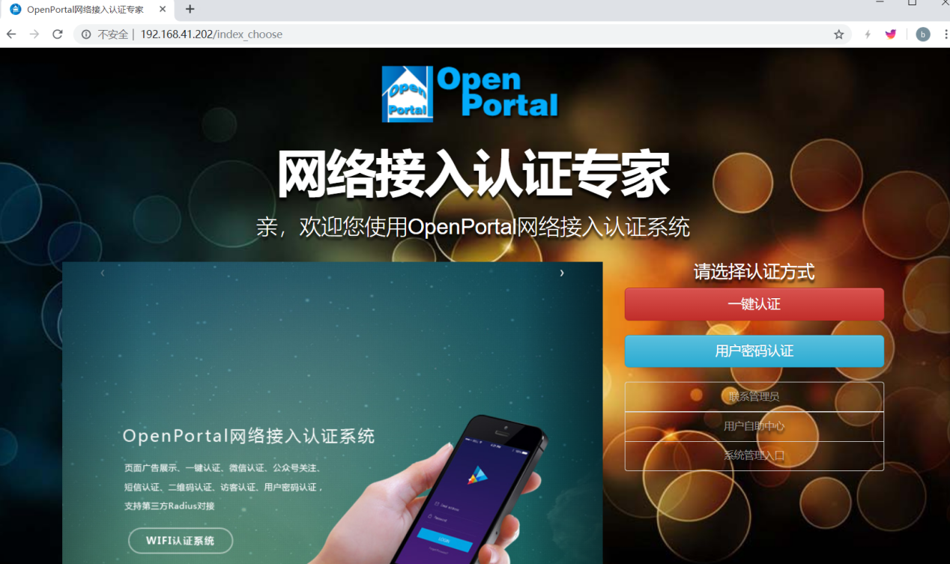
点击系统管理入口
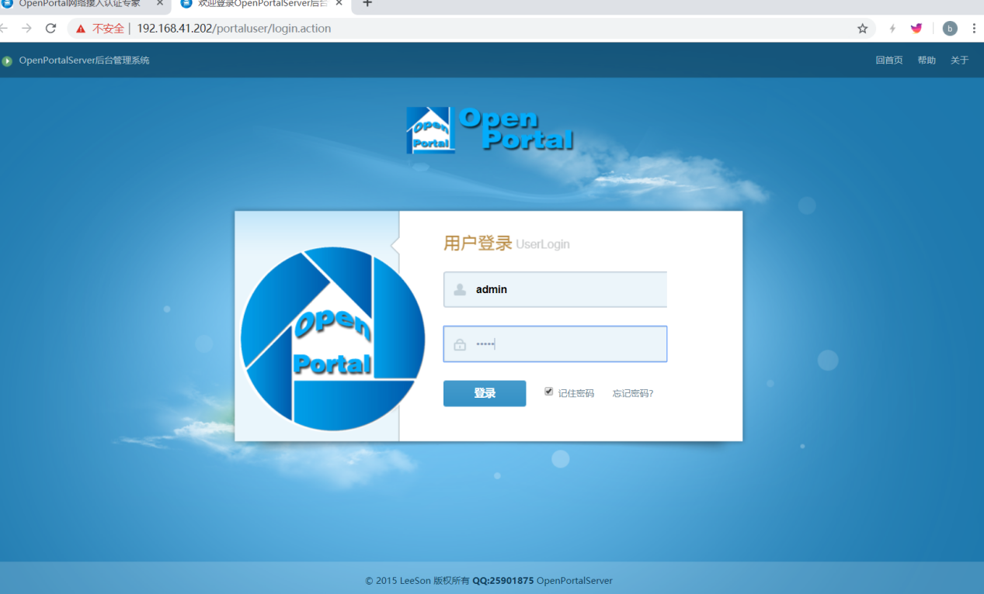
用户名密码为admin

展示界面
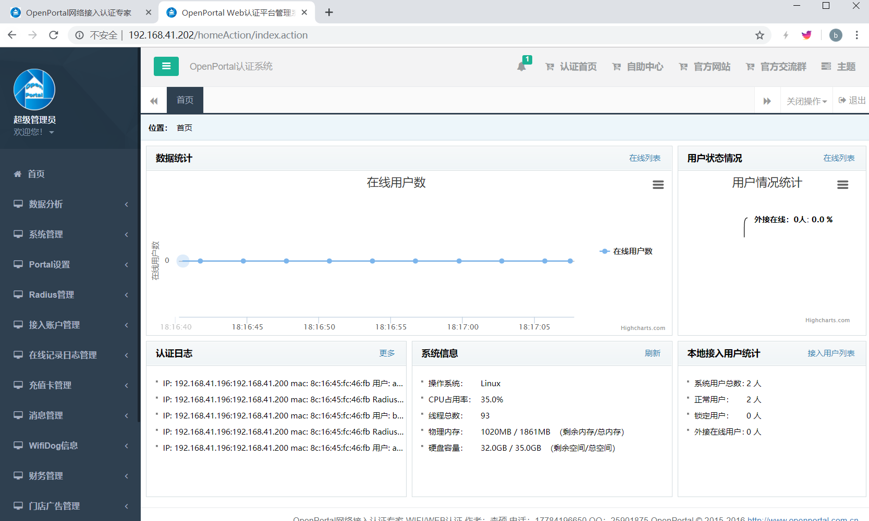




实验二：s5720+freeradius实现802.1x访问控制
实验目的：测试机通过freeradius和s5720交换机，申请访问互联网，查看认证用户名密码效果

2.1.实现流程
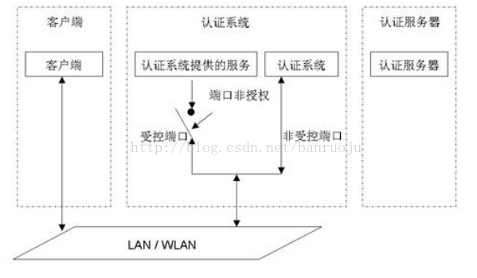

2.2实验过程

步骤一：部署freeradius（同上）
软件包：
freeradius-3.0.13-6.el7.x86_64

yum install freeradius freeradius-utils（可使用阿里yum源）

编辑/etc/raddb/users文件，取消测试用户相关信息的注释
sed -i '73,81s/^#//g' /etc/raddb/users

radius -X启动

radtest steve testing localhost 0 testing123测试命令
如果输出"Access-Accept packet" 表示成功了，"Access-Reject" 表示失败了。

创建radius表
create database radius;

配置freeradius对接数据库
cd /etc/raddb/mods-config/sql/main/mysql
cp setup.sql setup.sql.ori
egrep -v '^$|#' setup.sql.ori > setup.sql

CREATE USER 'radius'@'localhost';
SET PASSWORD FOR 'radius'@'localhost' = PASSWORD('radpass');
GRANT SELECT ON radius.* TO 'radius'@'localhost';
GRANT ALL on radius.radacct TO 'radius'@'localhost';
GRANT ALL on radius.radpostauth TO 'radius'@'localhost';

创建radius用户
source /etc/raddb/mods-config/sql/main/mysql/setup.sql;
use radius;
source /etc/raddb/mods-config/sql/main/mysql/schema.sql;

启用sql模块
ln -s /etc/raddb/mods-available/sql /etc/raddb/mods-enabled/
sed -i '31s/"rlm_sql_null"/"rlm_sql_mysql"/g' /etc/raddb/mods-enabled/sql
sed -i '87s/"sqlite"/"mysql"/g' /etc/raddb/mods-enabled/sql
sed -i '91,94s/#///g' /etc/raddb/mods-enabled/sql
sed -i '/read_clients = yes/s/#//g' /etc/raddb/mods-enabled/sql

chgrp -h radiusd /etc/raddb/mods-enabled/sql

添加开机启动
systemctl daemod-reload
systemctl enable mariadb.service
systemctl enable radiusd.service
sed-i'3aAfter=mariadb.service' /etc/systemd/system/multi-user.target.wants/radiusd.service

添加客户端
cp /etc/raddb/clients.conf /etc/raddb/clients.conf.ori
egrep -v '^$|#' /etc/raddb/clients.conf.ori > /etc/raddb/clients.conf

添加用户组
use radius
insert into radgroupreply (groupname,attribute,op,value) values ('user','Auth-Type',':=','Local');
insert into radgroupreply (groupname,attribute,op,value) values ('user','Service-Type',':=','Framed-User');
insert into radgroupreply (groupname,attribute,op,value) values ('user','Framed-IP-Address',':=','255.255.255.255');
insert into radgroupreply (groupname,attribute,op,value) values ('user','Framed-IP-Netmask',':=','255.255.255.0');

添加用户
insert into radcheck (username,attribute,op,value) values ('pc','Cleartext-Password',':=','111111');

insert into radusergroup (username,groupname) values ('pc','user');

测试命令radtest test testpwd localhost 1812 testing123

添加以下内容，client为可访问段，密钥为交换机radius模板密码
Vim /etc/raddb/clients.conf
client 192.168.41.0/21 {
secret = aaa
}

注：如连接ac后updatesql错误，请添加
连接ac后报错，在mysql中添加
use radius;
DROP TABLE radacct;
CREATE TABLE radacct (
radacctid bigint(21) NOT NULL auto_increment,
acctsessionid varchar(64) NOT NULL default '',
acctuniqueid varchar(32) NOT NULL default '',
username varchar(64) NOT NULL default '',
groupname varchar(64) NOT NULL default '',
realm varchar(64) default '',
nasipaddress varchar(15) NOT NULL default '',
nasportid varchar(15) default NULL,
nasporttype varchar(32) default NULL,
acctstarttime datetime NULL default NULL,
acctupdatetime datetime NULL default NULL,
acctstoptime datetime NULL default NULL,
acctinterval int(12) default NULL,
acctsessiontime int(12) unsigned default NULL,
acctauthentic varchar(32) default NULL,
connectinfo_start varchar(50) default NULL,
connectinfo_stop varchar(50) default NULL,
acctinputoctets bigint(20) default NULL,
acctoutputoctets bigint(20) default NULL,
calledstationid varchar(50) NOT NULL default '',
callingstationid varchar(50) NOT NULL default '',
acctterminatecause varchar(32) NOT NULL default '',
servicetype varchar(32) default NULL,
framedprotocol varchar(32) default NULL,
framedipaddress varchar(15) NOT NULL default '',
PRIMARY KEY (radacctid),
UNIQUE KEY acctuniqueid (acctuniqueid),
KEY username (username),
KEY framedipaddress (framedipaddress),
KEY acctsessionid (acctsessionid),
KEY acctsessiontime (acctsessiontime),
KEY acctstarttime (acctstarttime),
KEY acctinterval (acctinterval),
KEY acctstoptime (acctstoptime),
KEY nasipaddress (nasipaddress)
) ENGINE = INNODB;

步骤二：配置华为5720
配置文件:
<HUAWEI>
<HUAWEI>dis cu
!Software Version V200R010C00SPC600
#
sysname HUAWEI
#
vlan batch 10
#
authentication-profile name default_authen_profile
authentication-profile name dot1x_authen_profile
authentication-profile name mac_authen_profile
authentication-profile name portal_authen_profile
authentication-profile name dot1xmac_authen_profile
authentication-profile name multi_authen_profile
authentication-profile name p1
dot1x-access-profile d1
access-domain huawei.com force
#
dhcp enable
#
diffserv domain default
#
radius-server template default
radius-server template rd1
radius-server shared-key cipher %^%#/V/P-"j|W-F}B1G'dIW4MyBt,>fPI69CjVQ)L.U*%^%#
radius-server authentication 192.168.41.226 1812 weight 80
#
free-rule-template name default_free_rule
#
portal-access-profile name portal_access_profile
#
drop-profile default
#
aaa
authentication-scheme default
authentication-scheme radius
authentication-mode radius
authentication-scheme abc
authentication-mode radius
authorization-scheme default
accounting-scheme default
local-aaa-user password policy administrator
password expire 0
domain default
authentication-scheme radius
radius-server default
domain default_admin
authentication-scheme default
domain huawei.com
authentication-scheme radius
radius-server rd1
local-user admin password irreversible-cipher $1a$PI<6+Z|n`D$M|$S7jb):H.{CL~%:*E)]84.B>`D>JUb)/IO.+['$
local-user admin privilege level 15
local-user admin service-type terminal http
#
interface Vlanif1
#
interface Vlanif10
ip address 192.168.41.200 255.255.248.0
dhcp select relay
dhcp relay server-ip 192.168.41.1
#
interface MEth0/0/1
#
interface GigabitEthernet0/0/1
#
interface GigabitEthernet0/0/2
#
interface GigabitEthernet0/0/3
#
interface GigabitEthernet0/0/4
#
interface GigabitEthernet0/0/5
#
interface GigabitEthernet0/0/6
#
interface GigabitEthernet0/0/7
#
interface GigabitEthernet0/0/8
#
interface GigabitEthernet0/0/9
#
interface GigabitEthernet0/0/10
#
interface GigabitEthernet0/0/11
#
interface GigabitEthernet0/0/12
#
interface GigabitEthernet0/0/13
#
interface GigabitEthernet0/0/14
#
interface GigabitEthernet0/0/15
#
interface GigabitEthernet0/0/16
#
interface GigabitEthernet0/0/17
#
interface GigabitEthernet0/0/18
#
interface GigabitEthernet0/0/19
#
interface GigabitEthernet0/0/20
#
interface GigabitEthernet0/0/21
#
interface GigabitEthernet0/0/22
#
interface GigabitEthernet0/0/23
#
interface GigabitEthernet0/0/24
#
interface GigabitEthernet0/0/25
#
interface GigabitEthernet0/0/26
#
interface GigabitEthernet0/0/27
#
interface GigabitEthernet0/0/28
#
interface GigabitEthernet0/0/29
#
interface GigabitEthernet0/0/30
#
interface GigabitEthernet0/0/31
#
interface GigabitEthernet0/0/32
#
interface GigabitEthernet0/0/33
#
interface GigabitEthernet0/0/34
#
interface GigabitEthernet0/0/35
#
interface GigabitEthernet0/0/36
#
interface GigabitEthernet0/0/37
#
interface GigabitEthernet0/0/38
#
interface GigabitEthernet0/0/39
#
interface GigabitEthernet0/0/40
#
interface GigabitEthernet0/0/41
#
interface GigabitEthernet0/0/42
#
interface GigabitEthernet0/0/43
#
interface GigabitEthernet0/0/44
#
interface GigabitEthernet0/0/45
#
interface GigabitEthernet0/0/46
port link-type access
port default vlan 10
#
interface GigabitEthernet0/0/47
port link-type access
port default vlan 10
authentication-profile p1
#
interface GigabitEthernet0/0/48
port link-type access
port default vlan 10
#
interface XGigabitEthernet0/0/1
#
interface XGigabitEthernet0/0/2
#
interface XGigabitEthernet0/0/3
#
interface XGigabitEthernet0/0/4
#
interface NULL0
#
user-interface con 0
authentication-mode aaa
user-interface vty 0 4
user-interface vty 16 20
#
dot1x-access-profile name dot1x_access_profile
dot1x-access-profile name d1
#
mac-access-profile name mac_access_profile

配置步骤:

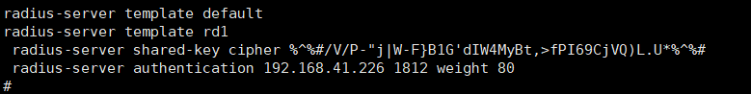
//设置radius模板为rd1
并设置radius密码radius服务器创建用户名密码
指向radius认证端口1812


//设置dot1x模板

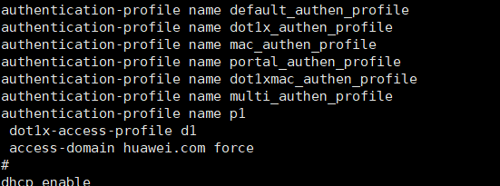

[HUAWEI]authentication-profile name p1 //配置模板并允许dot1x
[HUAWEI-authen-profile-p1]dis this
#
authentication-profile name p1
dot1x-access-profile d1
access-domain huawei.com force
#
return
[HUAWEI-authen-profile-p1]

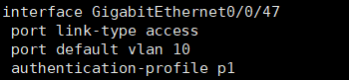
//设置47口认证模板p1

步骤三：配置win10开启802.1x认证
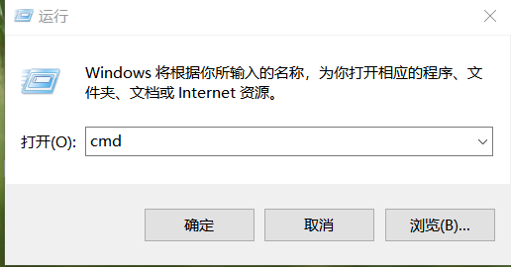//打开服务列表

//找到“Wired AutoConfig”与“WLAN Autoconfig”并右击开启
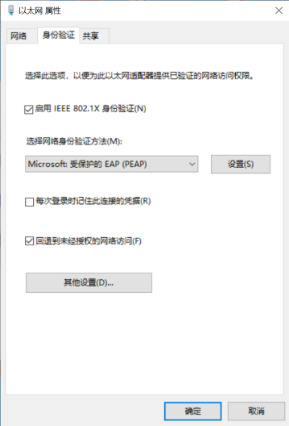// 控制面板|网络和 internet|网络连接 网卡开启802.1x
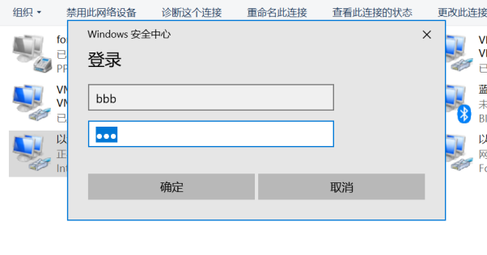//输入radius用户名密码
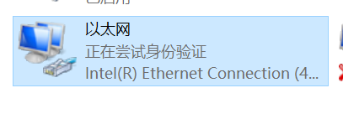//认证成功


步骤四：配置安卓手机开启802.1x认证

1)Android 2.6版本以上可直接点击搜索到的ECUST.1x进行配置，而2.6版本以下需手动“添加Wi-Fi网络”，手动添加时，“网络SSID”填写ECUST.1x，安全设定选择“802.1x EAP”或“802.1x 企业”；
2)“EAP方法”选择“PEAP”，“阶段2认证”选择“无”或“MSCHAPV2”，“CA证书”或“用户证书”选择“不验证”，“身份”和“密码”两栏输入无线网络用户帐号信息，“匿名身份”无需填写；
3)信息填好以后，点击“存储”或“连接”，则会自动连接ECUST.1x进行认证，若弹出证书确认窗口，选择“是”；
4)等待显示“已连接”，即可开始使用无线网络。

2.3实验结果
弹出认证界面为win10自带界面，和安卓自带界面

实验三：captive-portal
实验目的:用captive portal对网关服务器iptables控制，实现认证用户名密码可以访问互联网

3.1.实现流程
软件：Github：https://github.com/nikosft/captive-portal
wifi 192.168.41.198网关指向captive-port，captive通过iptables控制接入流量通过认证和iptales放行

3.2实验过程

步骤：部署captive-portal

yum -y install httpd
Yum -y install iptables
//安装httpd和iptables

Systemctl stop firewalld.service
Systemctl start iptables
//关闭firewalld，并启用iptables

Unzip captive-portal-master.zip
Cd captive-portal-master
Vim captive-portal-master
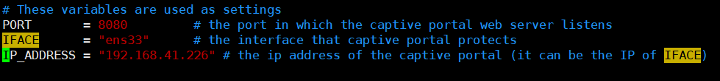
//更改port网卡和本地ip

//登录用户名密码

./captive_portal.py

通过连接wifi访问会得到以下效果
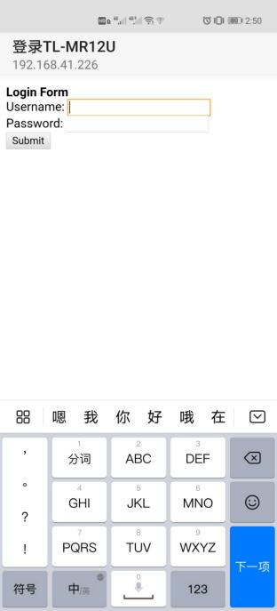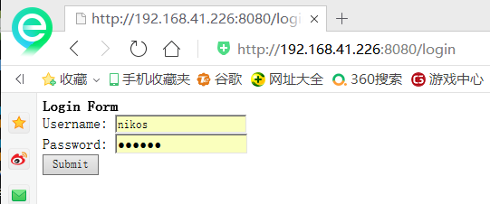

输出用户名密码后192.168.41.198wifi可以访问互联网

Iptables效果
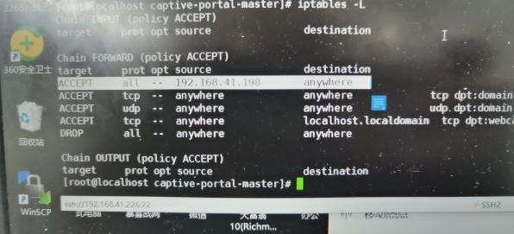

3.3实验结果
弹出认证界面为自定义界面，captive-portal可以通过iptables实现用户名密码认证

