Requested Information on Network Infrastructure and planning

Information Request

Purpose
The purpose of this document is to clarify and organize the need of information network security administration on matters related to the telecom operator’s infrastructure (here in Safaricom). This document was prepared in the form of questionnaire to make it simple and precise. We will use this document to design and implement our national security service.

Datacenter
Since some services might be deployed in the datacenter of the operator, it is very important to understand the real environment of operator’s datacenter. This information should be filled for all IGW and PE sites available on the telecom provider (here in Safaricom).
No. | ITEM | Description | Description
 | Site name | Kaliti | STEP HQ
 | City of site | Addis Ababa | Addis Ababa
 | Geographic location | Lat 8.921065,  Long 38.768908 | Lat 8.993507,  Long 38.776892
 | number of links (Gi interface) | 1*10G | 1*10G
 | type of link | Leased line | Leased line
 | Power Supply | DC/AC | DC/AC
 | CAD drawings of site | Attached | Attached
 | Method of wiring | Strong | Strong
 | Floor type | Solid Panel | Solid Panel
 | Air condition | Temperature 19 deg C  Humidity 50% | Temperature 19 deg C  Humidity 50%
 | Rack standard | Height 2100mm [47U]  Width 600mm  Depth 1200  Weight 1800Kg | Height 2100mm [47U]  Width 600mm  Depth 1200  Weight 1800Kg

Network
To be able to intercept and perform controlling policy on the network, first the operators’ network must be known to the law enforcement agencies. This information will provide clue on how to engage with mentioned activities.
No. | ITEM | Description
1 | High Level Network Design | Provided below
2 | IP planning | Provided below
3 | NAT type and Location | CGNAT in both Core locations
4 | percent of asymmetric traffic in IGW/PE | To be determined based on user traffic patterns
5 | Interface information of IGW/PE network device | 10GE  100GE
6 | Optical module information of IGW/PE network device | 10GE SFP+  100GE QSFP28
7 | Model type of peer transmission device of the IGW/PE device | Uplink to Ethiotel Transmission Equipment
8 | Interface information of peer transmission device of the IGW/PE device (Gi interface) | Uplink to Ethiotel Transmission Equipment  [10GE]
9 | Optical module information of peer transmission device of the IGW/PE device (Gi interface) | Uplink to Ethiotel Transmission Equipment
10 | number of links (Gi interface) | 1*10G in each location
11 | type of link | Leased line
12 | CDN or catching mechanisms | No CDNs deployed at the moment.  Plan to deploy them connected to the IGW.

High Level Network Design
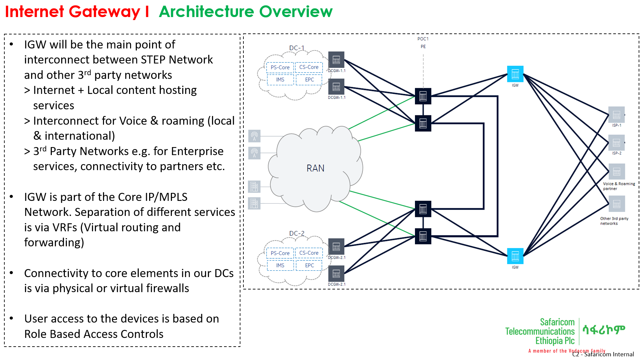
IP planning
Subnet address | Allocation
102.218.48.0/24 | Core Site 1 & 2
102.218.49.0/24 | IT & OSS Site & Shared Services
102.218.50.0/24 | Mobile Data Subscribers Site 1
102.218.51.0/24 | Mobile Data Subscribers Site 2

Interconnection between Telecom
To have a full understanding of how Safaricom and EthioTelecom operate together, it’s very important to know how their network is interconnected each other. This becomes more important especially on IGW/PE sites.
No. | Telecom Provider 1 Site Name  (Safaricom Ethiopia) | Telecom Provider 2 Site Name  (Ethio Telecom) | Connection Type
1 | Kaliti | Nifas Silk, Microwave | 10G
2 | STEP HQ | Bole | 10G

IGW Deployment Strategy
The telecom service providers in our country have the right to establish their own IGW to provide services to their subscribers. The telecom providers might also share one or more IGW depending on the agreement made between both parties. Since law enforcement agencies need to intercept the network physically, it’s very important to know what kind of strategy the telecom service providers are implementing.
No. | Telecom Provider 1 Site Name  (Safaricom Ethiopia) | Telecom Provider 2 Site Name  (Ethio Telecom) | External Provider | Country
 | Kaliti | Microwave [Transmission Service only] | Safaricom Kenya | Kenya
 | STEP HQ | Bole [Transmission Service only] | Djibouti Telecom | Djibouti

Expansion Plan
Since most of the upgrade done from the telecom side affect the legal interception carried out by law enforcement agencies, it is very important to have a prior knowledge about the telecom’s expansion plan. This will make sure the services provided by the security sector won’t be interrupted and on the other side the business of the telecom provider also won’t be hindered.
No. | ITEM | Capacity | Upgrade Plan
 | IGW at Kaliti | 1*10G | 1*100G in 1 year
 | IGW at STEP HQ | 1*10G | 1*100G in 1 year

