22-11-version.zip升级包更新说明
文件：V22.11_29__add_seq_cycle_region_id_20230221.sql
MD5：d41d8cd98f00b204e9800998ecf8427e
将 V22.11_29__add_seq_cycle_region_id_20230221.sql 文件拖拽替换至 22-11-version.zip升级包中
压缩包目录：22-11-version.zip\22-11-version\tsg-online\roles\bifang-api\file\upgradesql

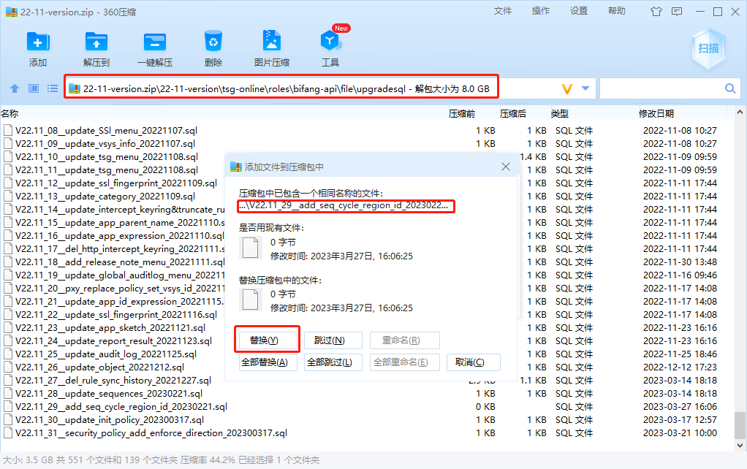

22-11-version.zip替换后 MD5: e6f2814a7bb2eb3ef3b018e66b7fd344

