Critical Dos Events

Critical Dos Events统计
统计2022-09-01~2023-03-16时间段内，Dos Events里Severity=Critical的日志信息，
Top 3 Destination IP分别为：
197.156.74.223：236次
197.156.74.222：166次
142.202.48.99：133次
详情如下：
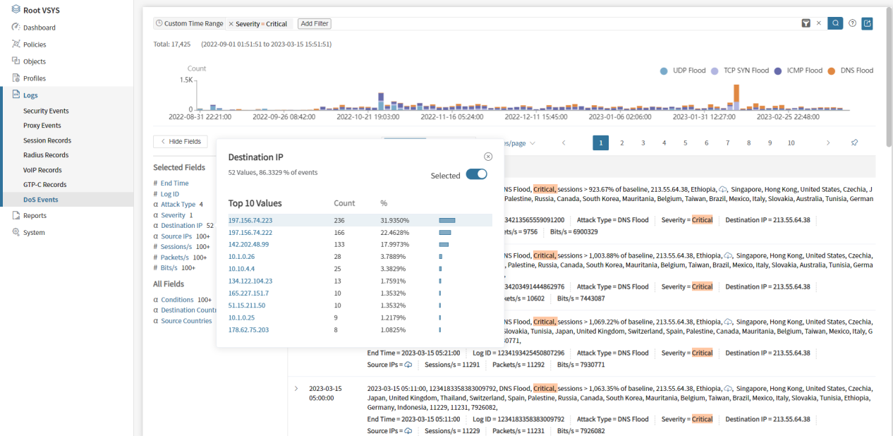

Top Destination IP 分析

Top1:197.156.74.223
dns2.ethiotelecom.et
Location: Amara Bahir Dar

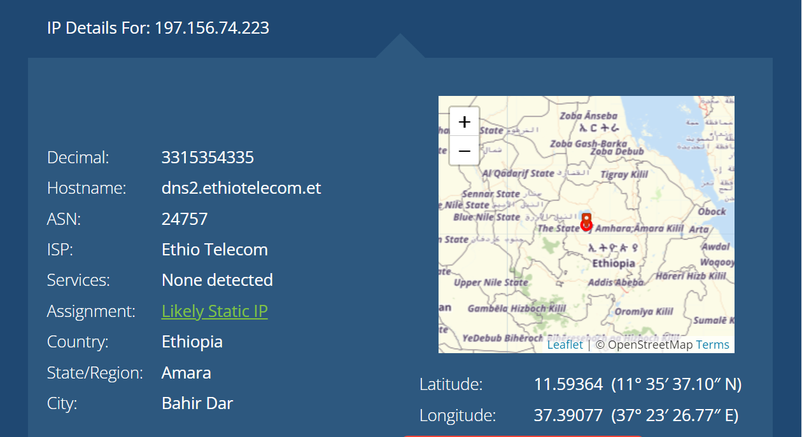

Top 2 :197.156.74.222
dns1.ethiotelecom.et
Location: Amara Bahir Dar

TOP 3 :142.202.48.99
99-48-202-142.clients.gthost.com
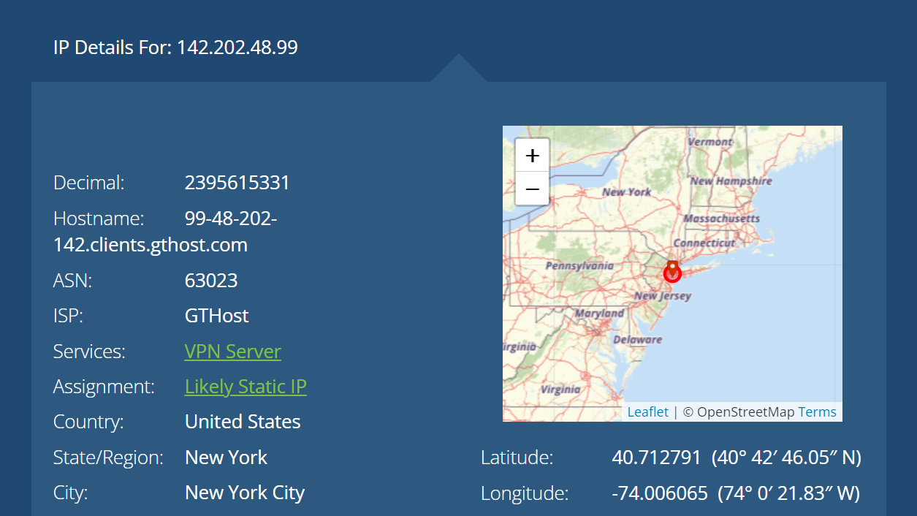

TOP 2 Destination IP of outside to Ethiopia attack

Top1:197.156.74.223
Attack Duration time:
2022-10-08 02:24:00~ongoing

Attack Type:
Attack Type | Start time | End time | Proportion  (2022-10-08-to now) | Proportion  (2023-03-09-to now)
ICMP Flood | 2022-10-08 02:24:00 | ongoing | 83.10% | 50%
DNS Flood | 2023-03-09 16:30:00 | ongoing | 16.89% | 50%
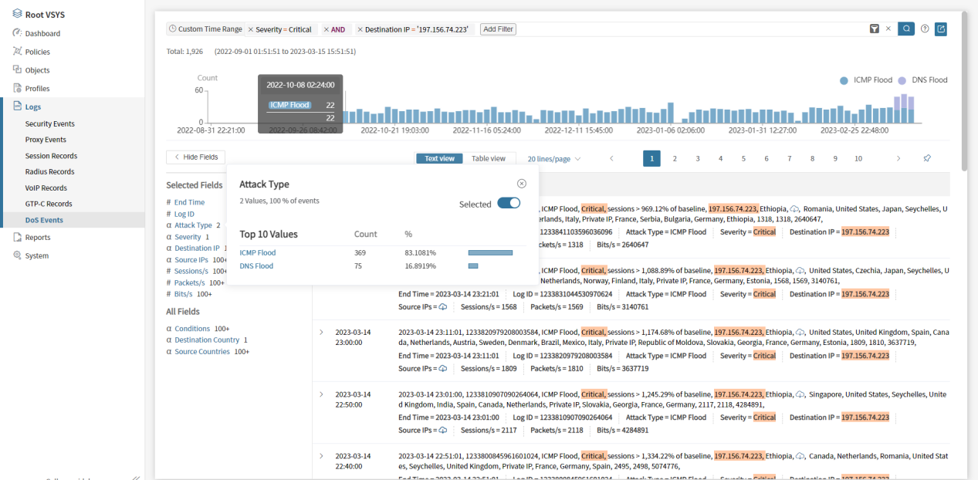

Top2:197.156.74.222
Attack Duration time:
2022-10-08 08:36:00~ongoing

Attack Type:
ICMP Flood

Now Period time of Attack
19:00:00~24:00:00
