Site migration operations documentation

Background
- According to the change requirements, SSM-PE was migrated to SHQ-IGW and adm-PE was migrated to KLT-IGW
- This document uses SSM-PE migration to SHQ-IGW as an example

Confirm the COM port
Insert the USB end of the console into the USB port of the computer-->Right-click this computer->Click Manage-->Select Device Manager-->Click Port--> get the COM port number
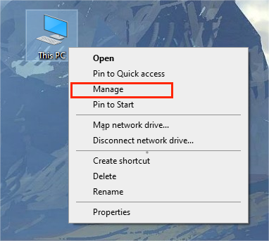
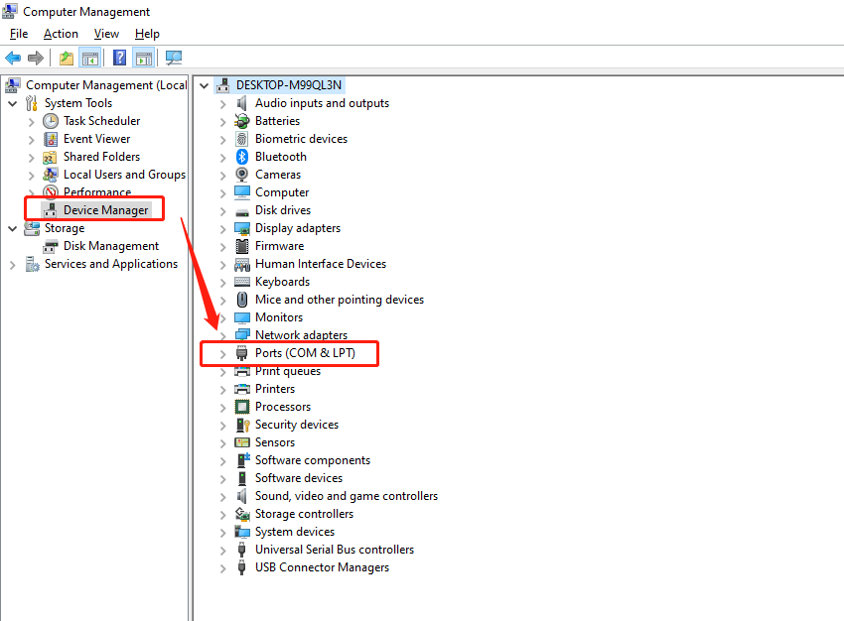

Confirm the baud rate of the serial port
- SMBIO, SMBCX, NPB, AND OPD are all 115200
- The Switch is 9600

Modify SMBIO hostname + IP

Log in to SMBIO

Plug the console cable network port into the RJ45 management serial port of SMBIO, and insert the USB end into the laptop USB port
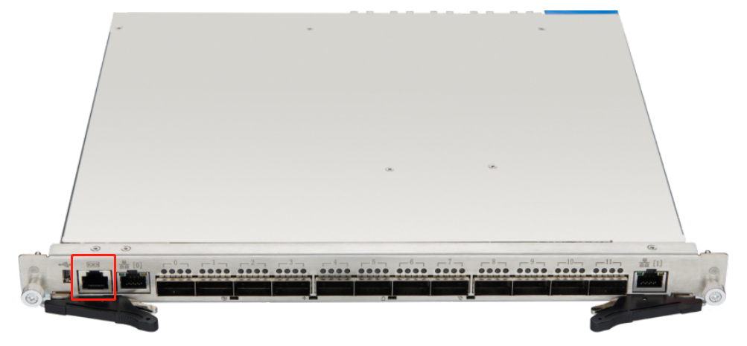

Configure xshell
Create a new session
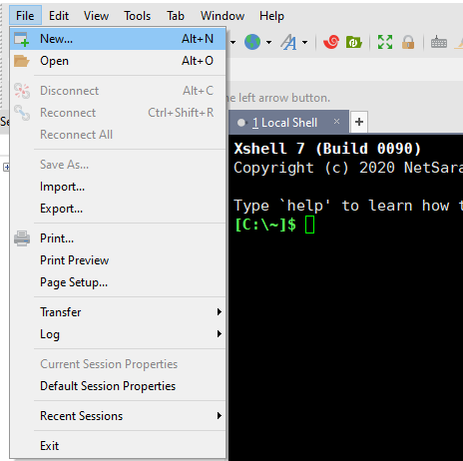
Select SERIAL, select the port according to step 2, and select Baud Rate according to step 3
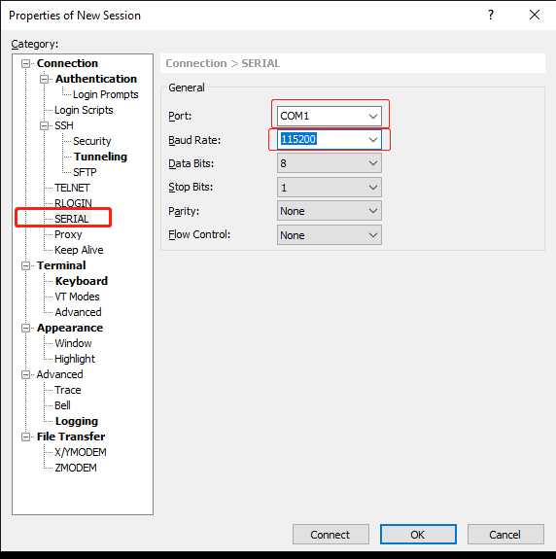
Click Connect
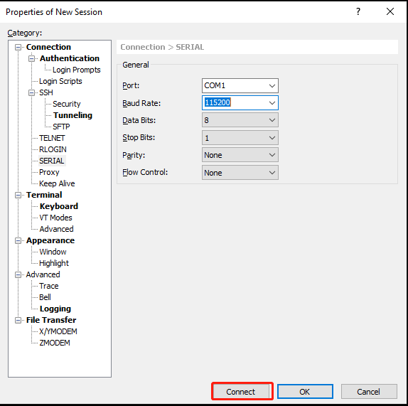

Modify the hostname
root@SSM-PE-T9K001-SMBIO-1:~# fw_setenv hostoverride SHQ-IGW-T9K001-SMBIO

Modify IP
root@ SSM-PE -T9K001-SMBIO-1:~# fw_setenv mgmtipaddr 10.218.2.1
root@ SSM-PE -T9K001-SMBIO-1:~# fw_setenv mgmtnetmask 255.255.255.0
root@ SSM-PE -T9K001-SMBIO-1:~# fw_setenv mgmtgateway 10.218.2.254

Restart SMBIO
root@ SSM-PE -T9K001-SMBIO-1:~# reboot

Modify SMBCX hostname + IP

Log in to SMBCX

Plug the console line network port into the RJ45 management serial port of SMBX, and the USB end into the laptop USB port
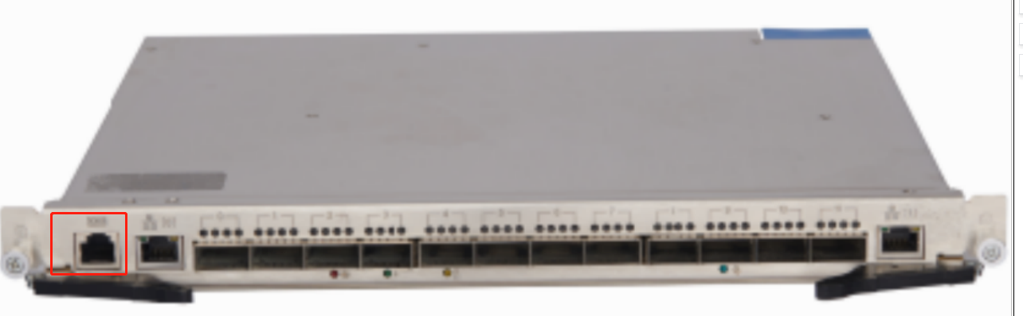

Configure xshell
Create a new session
Select SERIAL, select the port according to step 2, and select Baud Rate according to step 3
Click Connect

Modify the host name
[root@SSM-PE -T9K001-SMBCX-2 ~]# fw_setenv hostoverride SHQ-IGW-T9K001-SMBCX

Modify IP
[root@SSM-PE -T9K001-SMBCX-2 ~]# fw_setenv mgmtipaddr 10.218.3.1
[root@SSM-PE -T9K001-SMBCX-2 ~]# fw_setenv mgmtnetmask 255.255.255.0
[root@SSM-PE -T9K001-SMBCX-2 ~]# fw_setenv mgmtgateway 10.218.3.254

Restart SMBCX
[root@SSM-PE -T9K001-SMBCX-2 ~]# reboot

Modify NPB hostname + IP

Log in to NPB

Insert the console line network port into the NPB management serial port, and the USB end into the laptop USB port
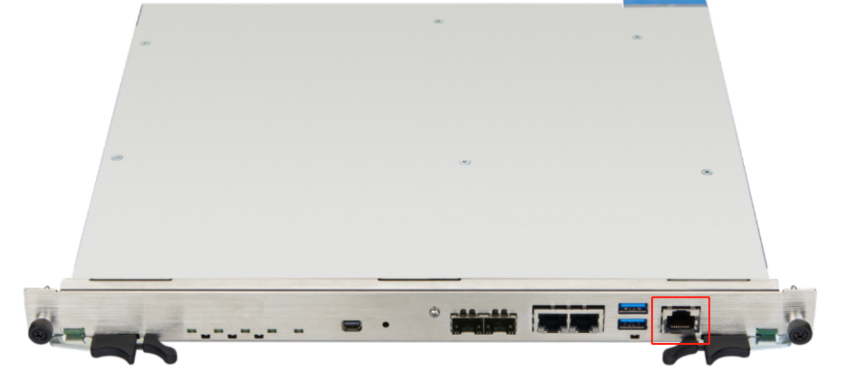

Configure xshell
Create a new session
Select SERIAL, select the port according to step 2, and select Baud Rate according to step 3
Click Connect

Modify the hostname
[admin@SSM-PE-T9K001-NPB01 ~]$
sudo hostnamectl set-hostname --static SHQ-IGW-T9K001-NPB01

Modify IP
[admin@SSM-PE-T9K001-NPB01 ~]$
sudo vim /etc/sysconfig/network-scripts/ifcfg-eth_vf_ctl

IPADDR=10.218.11.1
NETMASK=255.255.255.0
GATEWAY=10.218.11.254

Restart NPB
[admin@SSM-PE-T9K001-NPB01 ~]$ reboot

Modify OPD IP

Log in to OPD

Insert the console cable network port into the OPD management serial port, and the USB end into the laptop USB port
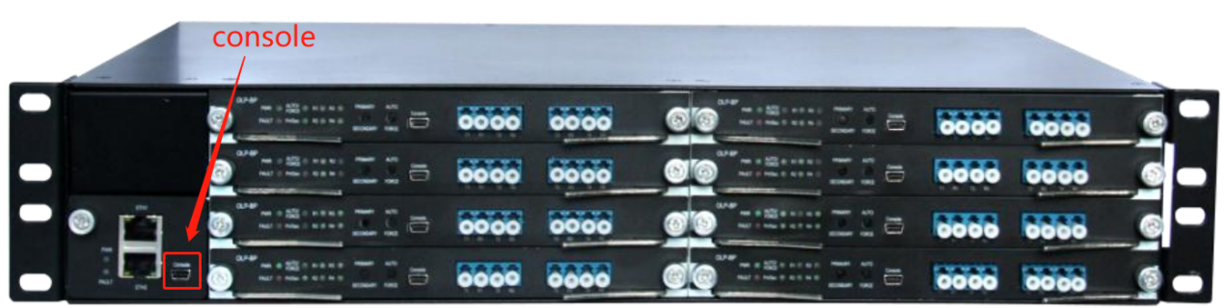

Configuring xshell
Create a new session
Select SERIAL, select the port according to step 2, and select Baud Rate according to step 3
Click Connect

Modify IP
CLI> ipconfig ip 10.218.4.1 255.255.255.0 10.218.4.254

Modify the server hostname + IP

Log in to the server
Log in to the server through the switch port

Log in to the management interface and enter the command line mode (>_Console)
https://10.226.12.1:8006/

Modify the PolicyBroker hostname + IP

Modify the host name
[root@SSM-PE-KVM-PB001 ~]# hostnamectl set-hostname --static SHQ-IGW-KVM-PB001

Modify the IP
[root@SSM-PE-KVM-PB001 ~]# vim /etc/sysconfig/network-scripts/ifcfg-eth0
IPADDR=10.218.12.2
NETMASK=255.255.255.0
GATEWAY=10.218.12.254
[root@SSM-PE-KVM-PB001 ~]# systemctl restart network

Modify NEZHA Agent hostname + IP

Modify the hostname
[root@SSM-PE-KVM-NZ001 ~]# hostnamectl set-hostname --static SHQ-IGW-KVM-NZ001

Modify IP
[root@SSM-PE-KVM-NZ001 ~]# vim /etc/sysconfig/network-scripts/ifcfg-eth0
IPADDR=10.218.12.3
NETMASK=255.255.255.0
GATEWAY=10.218.12.254
[root@SSM-PE-KVM-NZ001 ~]# systemctl restart network

Modify the Data Transporter hostname + IP

Modify the hostname
[root@SSM-PE-KVM-DT001 ~]# hostnamectl set-hostname --static SHQ-IGW-KVM-DT001

Modify the IP
[root@SSM-PE-KVM-DT001 ~]# vim /etc/sysconfig/network-scripts/ifcfg-eth0
IPADDR=10.218.12.4
NETMASK=255.255.255.0
GATEWAY=10.218.12.254
[root@SSM-PE-KVM-DT001 ~]# systemctl restart network

Modify the host IP
root@SSM-PE-SERVER001:~# vim /etc/network/interfaces
address 10.218.12.1/24
gateway 10.218.12.254
root@SSM-PE-SERVER001:~# systemctl restart networking

Modify the Switch

Log in to Switch

Insert the console line network port into the Swith management serial port, and the USB end into the laptop USB port
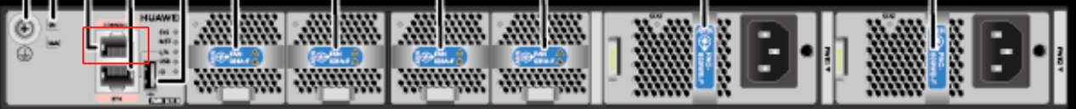

Configuring xshell
Create a new session
Select SERIAL, select the port according to step 2, and select Baud Rate according to step 3
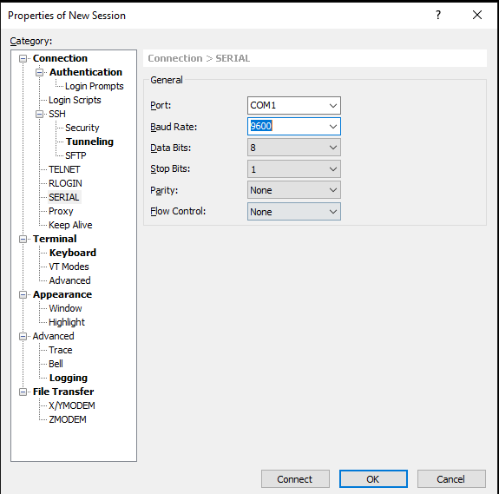
Click Connect

Modify the hostname
<SSM-PE-ASW-01>sys
[~SSM-PE--ASW-01]sysname SHQ-IGW-ASW-01

Modifying Vlanif
interface Vlanif2002
ip address 10.218.2.254 255.255.255.0
#
interface Vlanif2003
ip address 10.218.3.254 255.255.255.0
#
interface Vlanif2004
ip address 10.218.4.254 255.255.255.0
#
interface Vlanif2011
ip address 10.218.11.254 255.255.255.0
#
interface Vlanif2012
ip address 10.218.12.254 255.255.255.0
#
interface Vlanif2140
ip address 10.218.140.254 255.255.255.0

Modifying ospf
ospf 1
area 0.0.0.22
network 10.218.2.0 0.0.0.255 description to SMB-IO Management
network 10.218.3.0 0.0.0.255 description to CSG SMB-Chassis-MGMT
network 10.218.4.0 0.0.0.255 description OPD
network 10.218.11.0 0.0.0.255 description NPB
network 10.218.12.0 0.0.0.255 description to Server Business
network 10.218.140.0 0.0.0.255 description to Server IPMI

Current status
- After a successful site migration:
- Access a 100G traffic to the 2023-02-03 STEP HQ IGW site system;
- Connect a 100G traffic to the 2023-02-07 Kaliti IGW site system.

