WMS验收URL测试

1.测试URL列表
http://i1.wp.com/soopermexican.com/wp-content/uploads/2010/04/Muhammad-Al-Buroq02.jpg
http://normalbobsmith.com/hatemail300.html
http://kextube.com/f/celebrity
http://3.bp.blogspot.com/-i7LuN4Xad8A/UYLO2msUF6I/AAAAAAAAN_Y/Rf7r8531o90/s1600/Mo+live+sketch.jpg
http://morethings.com/boutique/images/muhammed-aysha04.jpg
http://tomgrossmedia.com/MohammedCartoons.html
http://twitpic.com/1pepxz
http://static.fnac-static.com/multimedia/images_produits/ZoomPE/7/4/8/9782020902847.jpg
http://pbs.twimg.com/media/BoGWRR4IgAEjtDf.jpg
http://zombietime.com/mohammed_image_archive/islamic_mo_full/Mohammed_Edinb_13thC.jpg
http://i.ytimg.com/vi/VmED0gEW31w/0.jpg
http://lookingattheleft.com/wp-content/uploads/2010/05/MG_50732.jpg
http://zombietime.com/mohammed_image_archive/book_illos/MosesJesusMoNap.jpg
http://truthandgrace.com/Images/mohammad23.jpg
http://metabunker.dk/rackham/anmeldelse/anmeld080_eng.php
http://preoccupiedterritory.com/wp-content/uploads/2016/01/Muhammad-bomb-head.jpg
http://alra7ba.info/vb/imgcache/1766.imgcache
http://photos1.blogger.com/blogger/82/653/1600/bok.gif
http://zombietime.com/mohammed_image_archive/book_illos/mahoma_realista.JPG
http://boomerspeaks.com/IssueMuslimBarbarians.htm
http://wordview.co.uk/wp-content/uploads/2017/12/Image-1-700x700.jpg
http://dengekan.com/doc/2005/12/dec2005.htm
http://deweydraws.blogspot.com/2010_05_01_archive.html
http://t0.gstatic.com/images?q=tbn:ANd9GcQS1ewozP-YsDPQ8eUElp1TYAbDhsRXhm9HefL9JhljXAbSpP5UZA:2.bp.blogspot.com/-ruLxMLMZ-uc/Tf9hQ5t44PI/AAAAAAAAADM/bbT03Q9lRrU/s640/MuhammadTheLastProphet.jpg
http://thebalochistanpost.com/2020/05/%d8%aa%d8%b1%d8%a8%d8%aa-%d9%85%db%8c%da%ba-%db%81%d9%84%d8%a7%da%a9-%db%81%d9%88%d9%86%db%92-%d9%88%d8%a7%d9%84%d8%a7-%d9%85%db%8c%d8%ac%d8%b1-%d9%86%d8%af%db%8c%d9%85-%d8%a8%da%be%d9%b9%db%8c-%d8%a7/
http://mobileheart.com/funny-sms/urdu-islamic-sms-messages-15.aspx
http://thealmightyguru.com/Humor/Docs/Images/Muhammad/O-05.jpg
http://noobsforever.net/forums/viewtopic.php?t=1274
http://barking-moonbat.com/images/uploads/islamfusher_thumb.jpeg
http://schockwellenreiter.de/archiv/2006/02.html
http://quickmeme.com/img/dc/dcbbec7c8ec020e6c2778b9b2774dd86378acf93d8f864cba5b4b3bbee812937.jpg
http://asylum.rydas.com/wp-content/uploads/2010/05/bomb-150x150.jpg
http://atheisme.org/charlie-hebdo-mahomet.html
http://docstoc.com/docs/124819244/the-life-of-muhammad
http://tawhed.ws/a?a=hasnazdy
http://images.uncyclomedia.co/uncyclopedia/en/thumb/e/ea/Raptor_Muhammad.jpg/200px-Raptor_Muhammad.jpg
http://login-guide.com/facebook-sign-up-create-your-facebook-account-the-easy-way/#ixzz1THnJmrii
http://i2.kym-cdn.com/photos/images/original/000/051/833/29121_126508047376297_100000513066384_274024_4236039_n.jpg
http://forum.tastyspleen.net/quake/index.php?topic=13215.0
http://smalldeadanimals.com/archives/016989.html

2.测试方式
测试终端公网地址


2.1.配置火狐浏览器

2.1.1.关闭HTTPS-Only模式


2.1.2.清除缓存、历史记录等
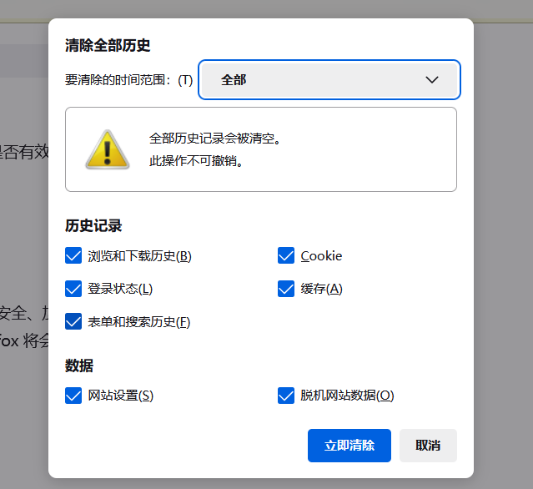

2.1.3.关闭火狐浏览器

2.2.打开wireshark进行抓包

2.3.批量打开URL列表
打开火狐浏览器，使用插件批量打开URL列表，并记录时间(时间均为巴基斯坦当地时间UTC+5)
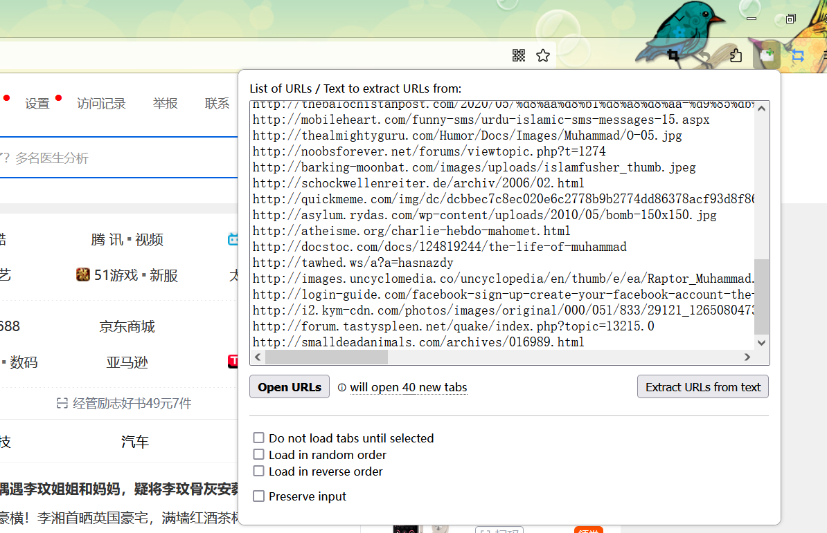

2.4.等待所有页面停止加载，记录时间，结束抓包

3.测试记录

3.1.第一次测试
打开URL列表时间19:00:10
所有页面停止加载时间19:04:20
数据包名称：20230824190010.pcap
可以打开的URL列表
序号 | URL | 备注
1 | http://t0.gstatic.com/images?q=tbn:ANd9GcQS1ewozP-YsDPQ8eUElp1TYAbDhsRXhm9HefL9JhljXAbSpP5UZA:2.bp.blogspot.com/-ruLxMLMZ-uc/Tf9hQ5t44PI/AAAAAAAAADM/bbT03Q9lRrU/s640/MuhammadTheLastProphet.jpg | 走CDN
2 | http://asylum.rydas.com/wp-content/uploads/2010/05/bomb-150x150.jpg

3.2.第二次测试
打开URL列表时间19:07:10
所有页面停止加载时间19:11:10
数据包名称：20230824190710.pcap
可以打开的URL列表
序号 | URL | 备注
1 | http://t0.gstatic.com/images?q=tbn:ANd9GcQS1ewozP-YsDPQ8eUElp1TYAbDhsRXhm9HefL9JhljXAbSpP5UZA:2.bp.blogspot.com/-ruLxMLMZ-uc/Tf9hQ5t44PI/AAAAAAAAADM/bbT03Q9lRrU/s640/MuhammadTheLastProphet.jpg | 走CDN
2 | http://mobileheart.com/funny-sms/urdu-islamic-sms-messages-15.aspx
3 | http://dengekan.com/doc/2005/12/dec2005.htm
4 | http://tomgrossmedia.com/MohammedCartoons.html

3.3.第三次测试
打开URL列表时间19:14:10
所有页面停止加载时间19:18:25
数据包名称：20230824191410.pcap
可以打开的URL列表
序号 | URL | 备注
1 | http://t0.gstatic.com/images?q=tbn:ANd9GcQS1ewozP-YsDPQ8eUElp1TYAbDhsRXhm9HefL9JhljXAbSpP5UZA:2.bp.blogspot.com/-ruLxMLMZ-uc/Tf9hQ5t44PI/AAAAAAAAADM/bbT03Q9lRrU/s640/MuhammadTheLastProphet.jpg | 走CDN
2 | http://zombietime.com/mohammed_image_archive/book_illos/mahoma_realista.JPG
3 | http://truthandgrace.com/Images/mohammad23.jpg

4.系统运行状态
测试时系统安装日志
securityEvents (2023-08-24T1850--1940).xlsx
策略验证情况
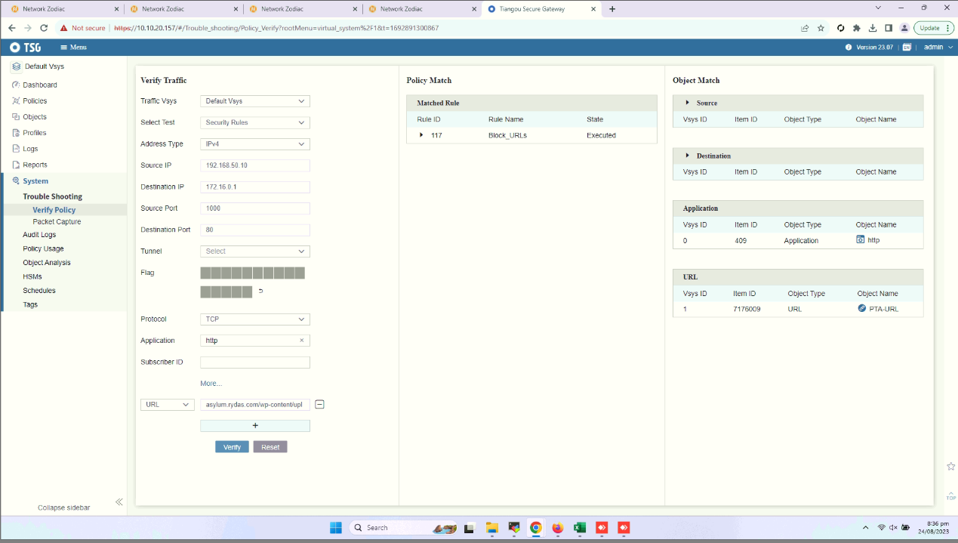
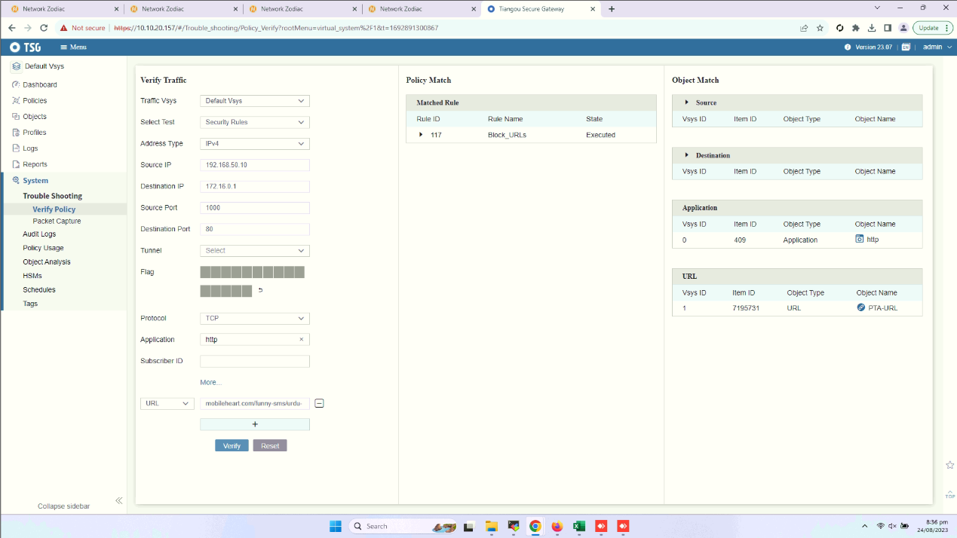
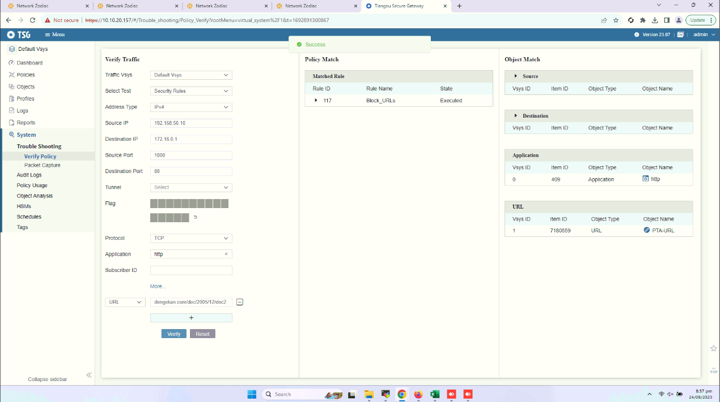
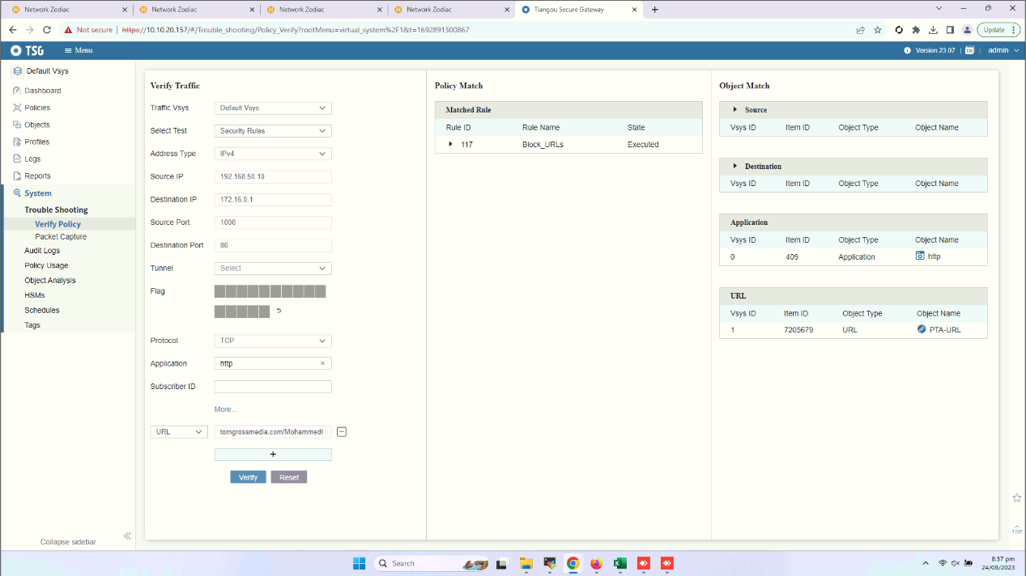
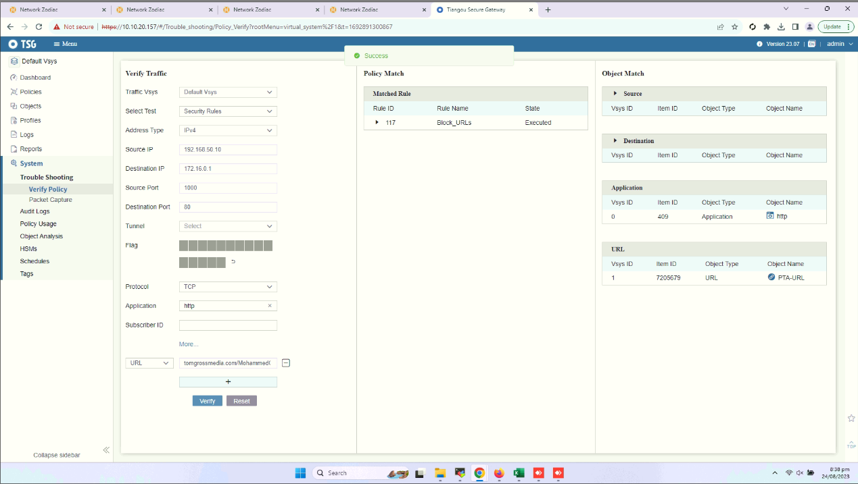
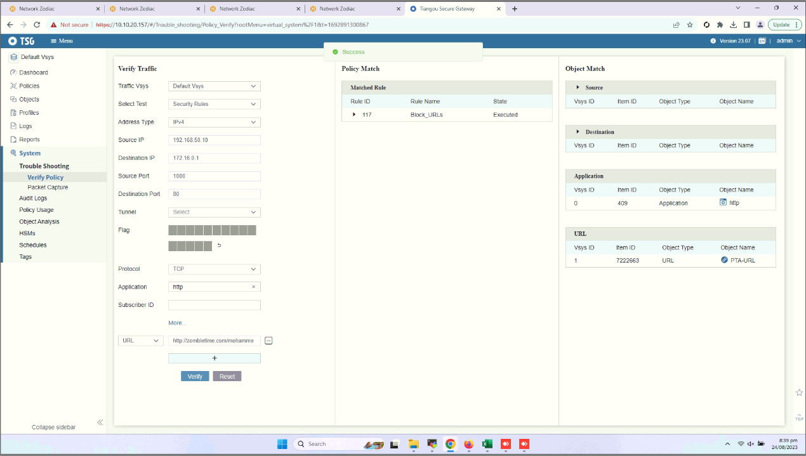
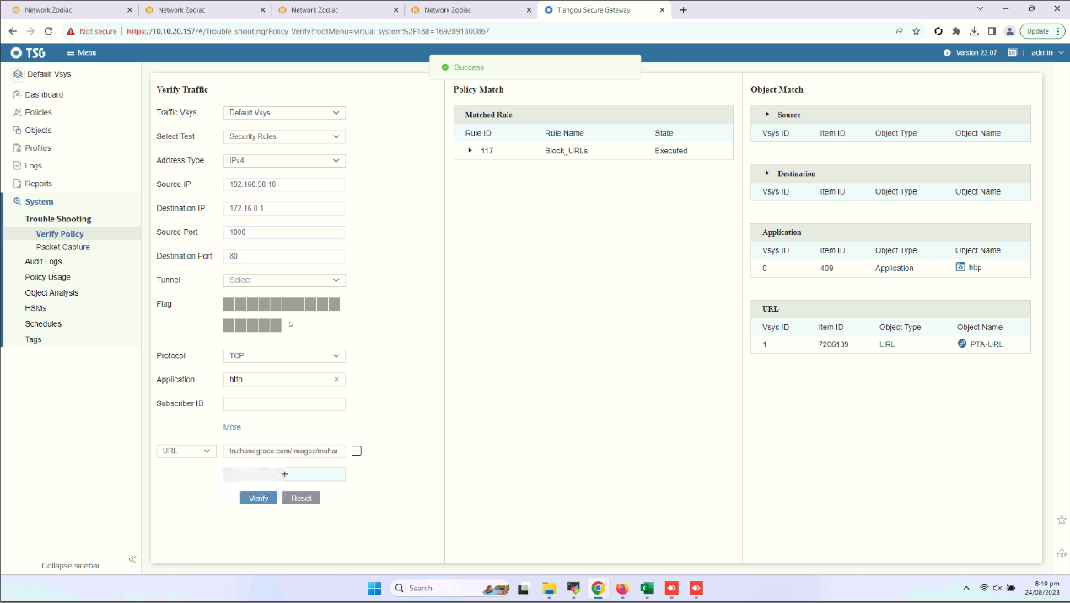
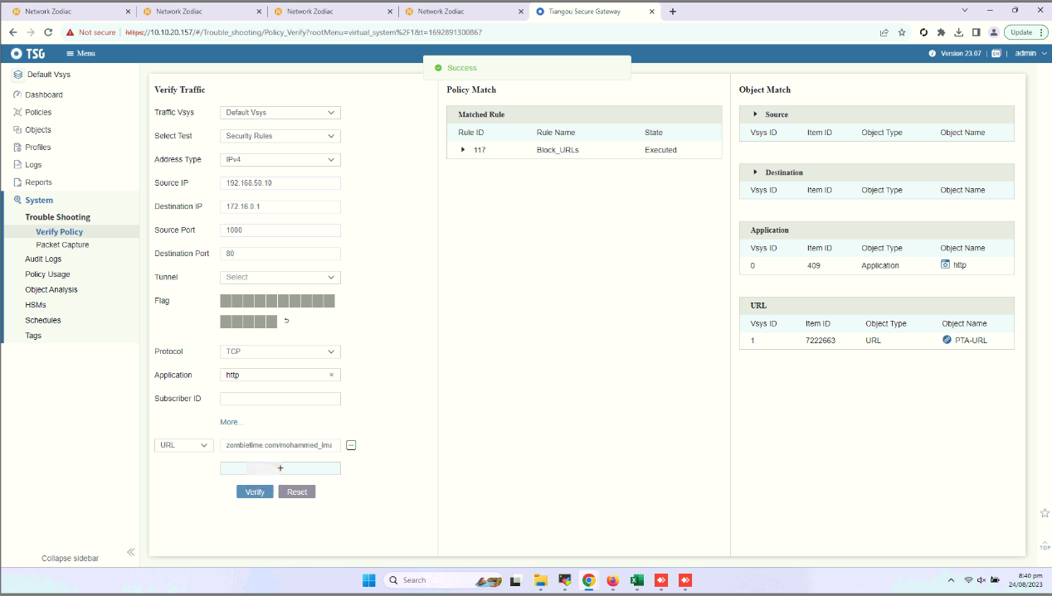
测试时间区间系统
未出现明显丢包情况
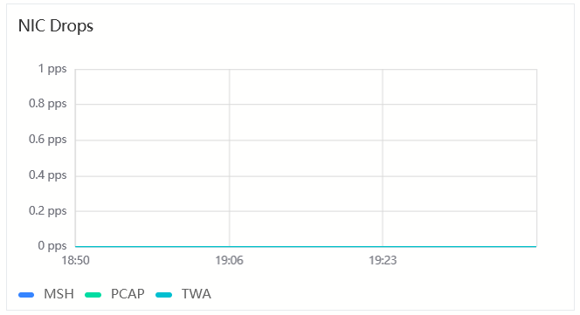
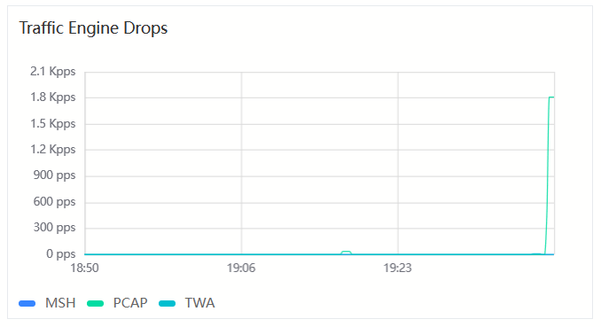
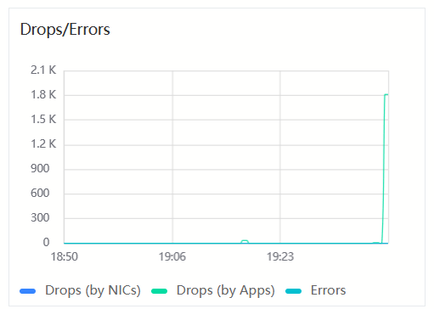
TSGX的Overload Protection值均为0

