TSG Block test for ask.com
Security policy applied
- *ask-privacy.my.onetrust.com
- *parallax.askmediagroup.com
- *ask.com

Effective Device
- All IGW sites

- I have applied the following policy on all IGW to block access to ask.com
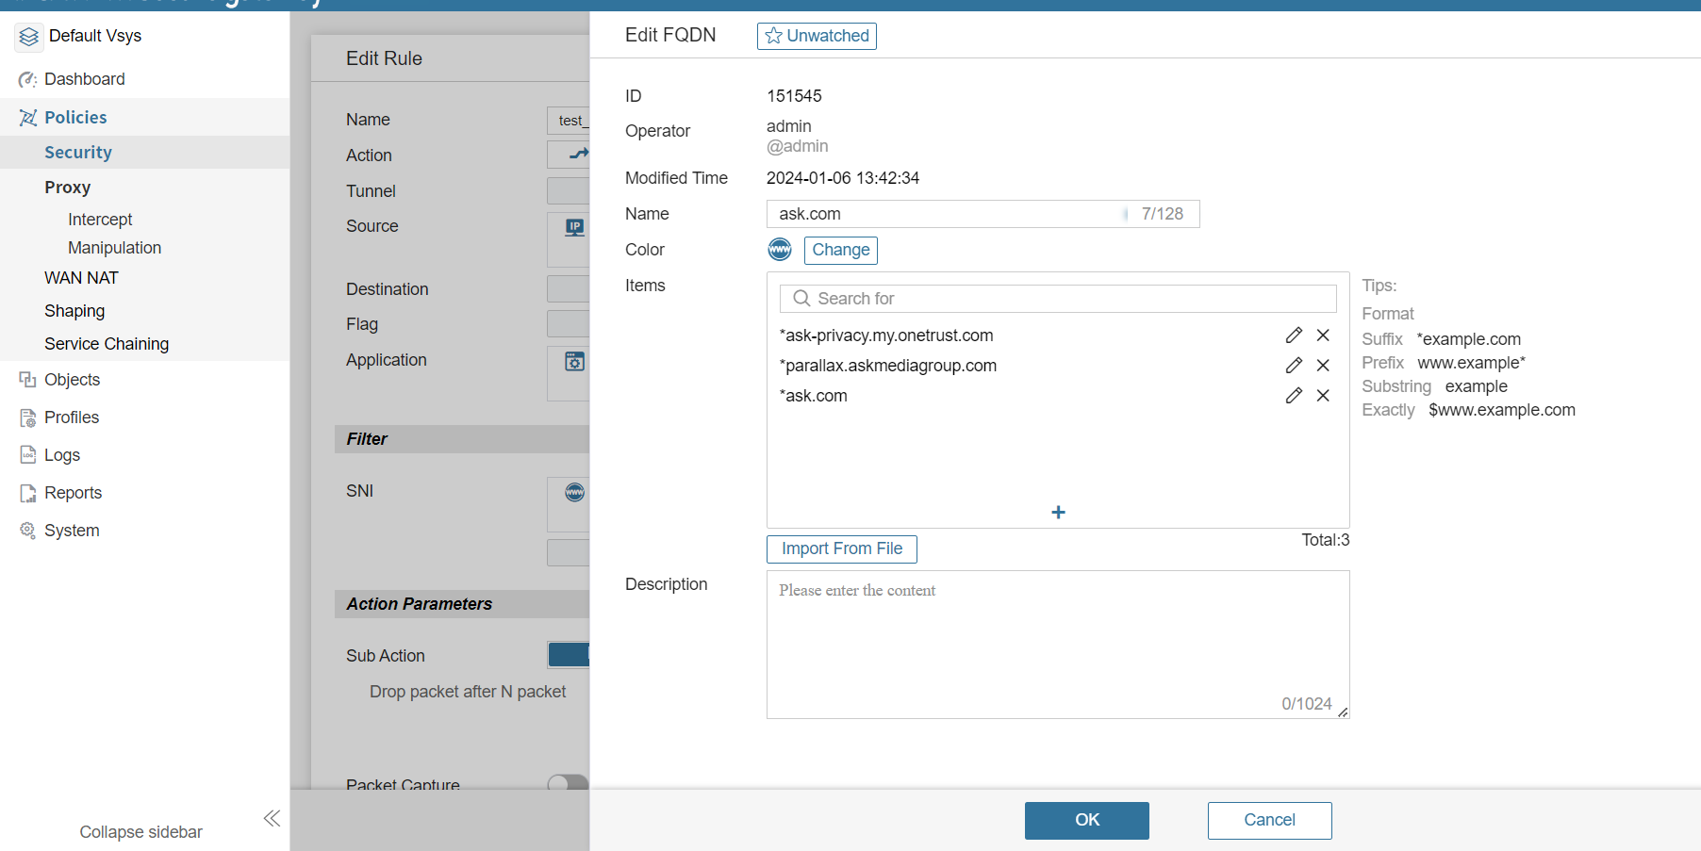

- And here is the Wireshark capture for it

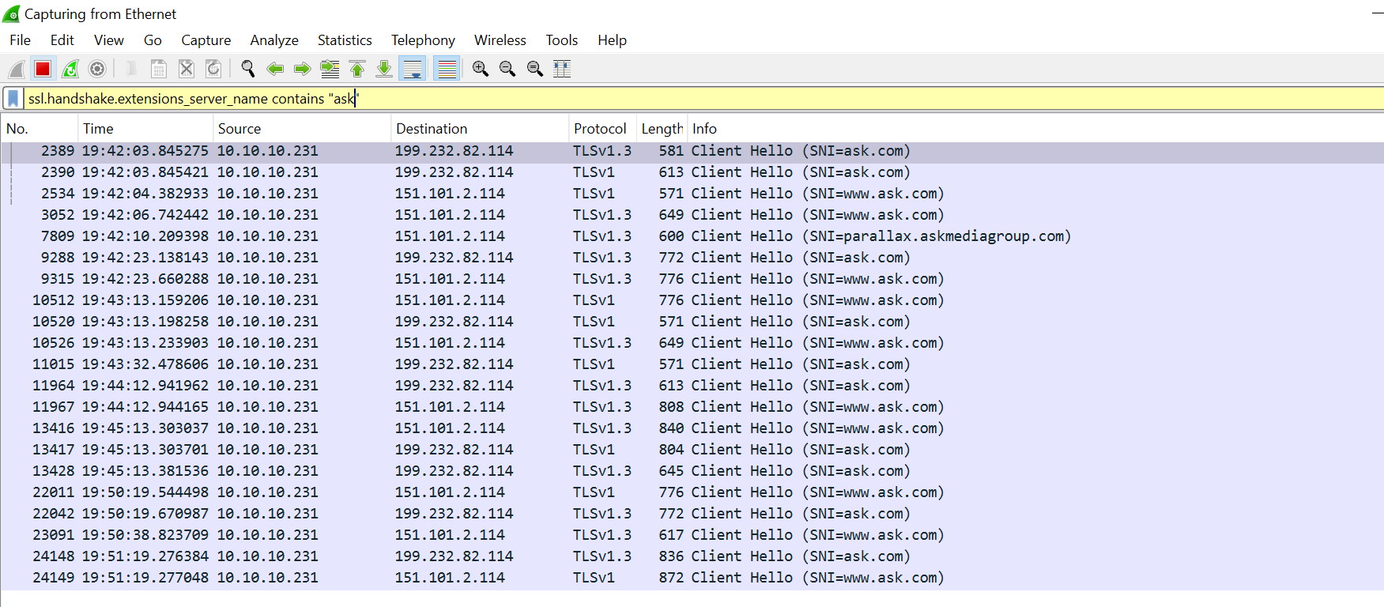

- But the website is still accessible as seen in the picture below
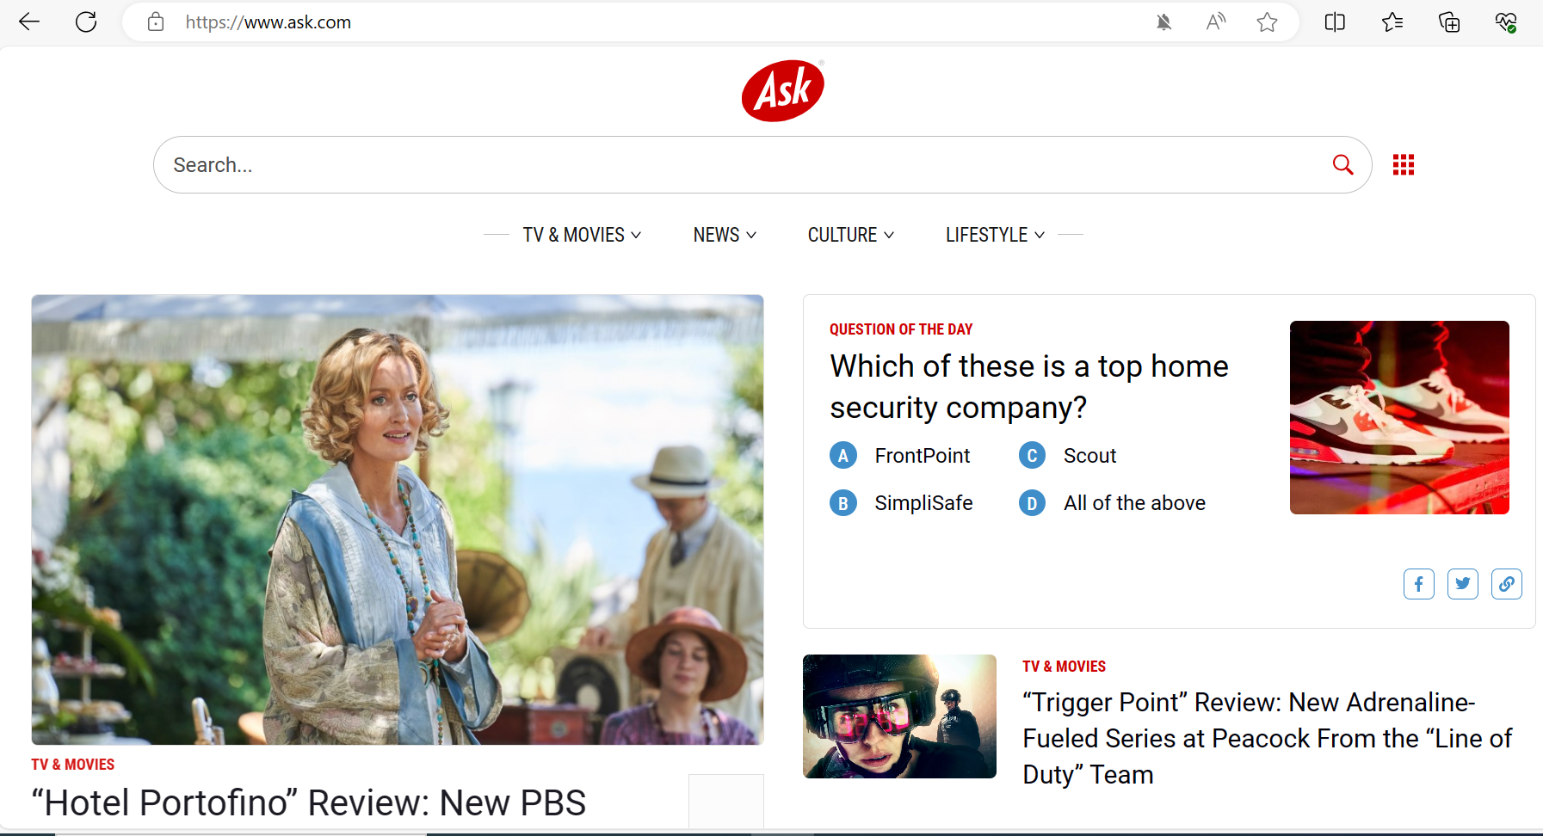

- And here we can see in the session record the traffic is passing through our devices
